**From Chaos to Order: Next-Gen IT Support Ticketing System**

Zyren Panao, Charli Maei Dizon, Rafael Umanos, Liah May De Luna, Christian Eric Aquino

College of Computing and Information Sciences, Systems Plus College Foundation

October 2023

**Author Note**

Zyren C. Panao

We have no known conflict of interest to disclose.

Correspondence regarding this research should be addressed to Zyren C. Panao, College of Computing and Information Sciences, Systems Plus College Foundation, Angeles City Pampanga

[ccis.zyren.panao@gmail.com](mailto:ccis.zyren.panao@gmail.com)

# APPROVAL SHEET

This Capstone project titled “**From Chaos to Order: Next-Gen IT Support Ticketing System**” prepared and submitted by *Zyren Panao, Charli Maei Dizon, Rafael Umanos, Liah May De Luna, and Christian Eric Aquino* in partial fulfillment of the requirements for the **Bachelor of Science in Information Technology**, has been examined and found in order and is hereby recommended for acceptance and approval for oral examination.

**JEFFREY L. EVANGELISTA, DIT**

    Adviser

After having been presented, it is hereby approved by the Committee on Oral Examination with a grade of ____.

**RENATO DAN A. PABLO II, DIT** **LIZA G. MANANQUIL, MIT**

        Member         Member

**GEORGE M. GRANADOS, MM, MIT**

Chairman

After having been recommended and approved, it is hereby accepted by the College of Computing and Information Sciences of Systems Plus College Foundation.

**GEORGE M. GRANADOS, MM, MIT           ROY D. DAYRIT, DIT**

Dean           VP for Academic Affairs

# Acknowledgement

The authors extend sincere gratitude to all individuals who contributed to the completion of this study. Special appreciation is extended to the management of Systems Plus College Foundation for their unwavering support. The authors acknowledge the invaluable guidance of academic advisors and mentors, as well as the cooperation of faculty members and IT support teams in data collection.

Thanks, are also due to peers and colleagues for their support, and to the author's family and loved ones for their encouragement throughout the research process. The authors express heartfelt appreciation to all who contributed to the successful completion of this study.

# Abstract

This study aims to design, develop, and implement a Next-Gen IT LAN-Based Support Ticketing System to enhance the efficiency, user experience, and collaborative capabilities of IT support processes. By addressing gaps in existing ticketing systems and incorporating advanced automation, user-focused design, and robust security measures, the developed system aims to streamline IT issue management and improve support team effectiveness. The research objectives were guided by the need to provide a comprehensive and intuitive platform that significantly enhances IT support workflows and resolves issues within diverse organizational landscapes. Data collection involved closed-ended and open-ended questions, as well as interviews, to gather insights into system functionality, usability, and performance. Results indicate positive feedback regarding the system's features, usability, and performance, with suggestions for further automation and improvement. Practical implications include informing IT professionals and organizations about the benefits of implementing advanced ticketing systems, while future research could explore long-term system effectiveness and integration of emerging technologies. Overall, this study contributes to the ongoing evolution of IT support systems, emphasizing the importance of user-centric design and continuous improvement in addressing modern organizational challenges.

*Keywords:* IT Service Management, Ticket Management Networks, Network Reliability, Internal Integration, User-Centric Design, Qualitative Methods, Thematic Analysis, Efficiency, Automation

# Table of Contents

Approval Sheet ii

Acknowledgement iii

Abstract iv

CHAPTER 1 The Problem and Its Settings 1

**Introduction 1**

**Background of the Study 4**

**Objectives of the Study 8**

**Scope and Limitation 9**

**Significance of the Study 11**

**Definition of Terms 12**

CHAPTER 2 Literature Review 14

**Conceptual Framework 29**

**Synthesis 30**

**Conclusion 32**

CHAPTER 3 Methodology 33

**Research Approach 33**

**Research Design 33**

**Data Collection 34**

**Data Analysis: 35**

**Data Validation and Reliability: 35**

**Ethical Consideration 35**

**System Development Methodology 36**

**Required Specification and Analysis 37**

**System Design Specification 40**

**Logical Specification 40**

**Physical Specification 40**

**Implementation 41**

**Testing and Evaluation 41**

CHAPTER 4 Results and Discussions 42

**Results 42**

**Data Presentation 42**

**Data Description 44**

**Qualitative Findings 45**

**Discussions 46**

**Interpretation 46**

**Comparison with Previous Research / System 47**

**Limitations 47**

**Potential Implications 48**

**Future Research 49**

CHAPTER 5 Conclusions and Recommendations 51

**Conclusion 51**

**Recommendations 52**

**Conclusion Statement 53**

REFERENCES 55

**APPENDICES**

**Appendix A Functional Decomposition of From Chaos to Order: Next-Gen IT Support Ticketing System**

**Appendix B Functional Decomposition of From Chaos to Order: Next-Gen IT Support Ticketing System**

**Appendix C Design Criterion for From Chaos to Order: Next-Gen IT Support Ticketing System**

**Appendix D System Interface User Account Page**

**Appendix E User’s Manual**

**Appendix F Evaluation Tools**

**Appendix G Curriculum Vitae**

# CHAPTER 1 The Problem and Its Settings

## Introduction

In the dynamic landscape of modern technology, where disruptions are the norm and challenges are the constant companions of progress, the role of an efficient IT support ticketing system becomes paramount. The people are at a crossroads, grappling with the chaos that often ensues when systems are inadequate, and demands are on the rise. It is in this intricate dance between user needs and technological advancements that the narrative of this study unfolds.

The traditional approaches to ticketing systems are no longer sufficient; the proponents stand at the precipice of a new era, one that demands innovation, foresight, and a meticulous blueprint for transforming disorder into a seamless symphony of IT support.

In the world of customer service management, a ticketing system stands out as a pivotal tool designed to process and systematically catalog customer service requests. Referred to as tickets, cases, or issues, these requests necessitate meticulous organization alongside relevant user information for effective resolution. The essence of a proficient ticketing system lies in its user-friendly interface, catering to the diverse needs of customer service representatives, managers, and administrators. Positioned as a central component in the domain of customer support, the efficiency of a ticketing system becomes paramount for streamlining operations, enhancing communication, and ensuring the prompt and efficient resolution of customer queries and concerns (Ashby, 2023).

The ticketing system is a help line of contact for all those query requestors who need help with their problem. The ticketing tool has a request module that functions as the help-line manager where all the requests are fetched from the users having queries related to their specific problem and then necessary solutions are provided to all those query-requestors by giving them the pre-defined solutions. If there is no solution predefined by the admin then the request for that query is passed on to the technician to resolve the issue (Gohil & Vikash Kumar, 2019).

The development of a comprehensive ticketing system for the ITS department at Systems Plus, College Foundation is critical for managing technical support requests and IT-related problems effectively. The system should provide an easy-to-use user interface for ticket submission, with separate categories for technical help and incidents. Improved response would result from automated classification and prioritizing based on urgency and effect. For smooth issue resolution, efficient ticket assignment, escalation processes, and real-time communication channels are essential. Integration with a dynamic knowledge base enables users to solve common problems on their own, while sophisticated reporting tools give insights for continual development. Data encryption and access restrictions, among other security measures, maintain the confidentiality of critical information. The system's efficacy is enhanced by seamless connection with current systems and mobile accessibility for on-the-go ticket handling. Regular evaluations and improvements, driven by user input, reinforce the system's position in streamlining the college's IT support operations.

A less-than-optimal ticketing system currently in place can pose some challenges for achieving peak efficiency in IT Service Management (ITSM). Without such a system, request handling becomes a manual and error-prone process, encompassing emails, phone calls, social media, and in-person interactions. This lack of automation hinders the effective capture, organization, and prioritization of requests. Additionally, the absence of a proper ticketing system leads to inefficiencies in organizing tickets into manageable categories, impacting timely assignment to the right teams. Manual tracking of ticket status results in labor-intensive tasks, affecting accountability and compliance with service-level agreements. The discussion emphasizes the crucial need for a ticketing system to track the life cycle of jobs, reduce oversight, and meet SLA requirements. Moreover, the absence of automated alerts and responses adds further challenges, impeding proactive incident management and burdening technicians with manual communication tasks. In summary, the focal point is the critical problem of lacking a helpdesk ticketing system, necessitating its implementation to enhance operational efficiency, customer service, and overall business productivity (Anthony, 2016).

Most often the new users in the IT Company need help to understand the new system which has been established to learn it. Here the ticketing system can help them by taking those query requests, then processing it to give the required solutions. Thus, the ticketing system can become the help line for all those query requesters and can save the organization from certain financial losses (Gohil & Vikash Kumar, 2019).

The evidence supporting the existence of challenges in the current state of ticketing systems within businesses is evident in several key scenarios. Many businesses are still relying on inefficient methods such as tracking support tickets in spreadsheets, leading to time-consuming processes prone to human error. The use of shared inboxes for ticket gathering hampers collaboration and may result in duplicate work and miscommunication. Difficulties in adding or modifying users and the inability to track inventory and products within the ticketing system further contribute to limitations on technician productivity. The absence of self-service options and analytics, along with the failure to leverage automation, highlights a significant gap in addressing modern customer expectations and optimizing operational efficiency. The repeated violation of Service Level Agreements (SLAs) emphasizes the tangible consequences of the existing issues. These challenges collectively underscore the pressing need for a more streamlined and technologically advanced approach to ticketing systems in businesses (Brudner, 2019),

To address the challenges articulated in the paper, the ideal solution involves the implementation of a robust helpdesk ticketing system. This system should seamlessly capture intelligently organize tickets into manageable categories, facilitating proper assignment based on team, priority, and other criteria. Real-time tracking of ticket status ensures accountability, with automated triggers for action to uphold service-level agreements. Customizable alerts notify technicians of critical statuses without overwhelming them. The system should enable efficient communication between technicians and end-users, allowing updates and notes within the platform. Choosing a system that enhances efficiency, is user-friendly, and supports scalability contributes to overall business profitability. Continuous review and optimization based on feedback ensures the system aligns with evolving business needs, making it a cornerstone for streamlined IT Service Management (Anthony, 2016).

## Background of the Study

Established on June 27, 1985, in Balibago, Angeles City, Systems Plus Inc. initially focused on conducting seminars for aspiring professionals entering the electronic data processing field. Expanding its offerings, the institution introduced associate courses like Electronics Service Technology, Computer Technology, Computer Secretarial, and Computer Science, tailored to meet the technical demands of the emerging Province of Pampanga. Renamed Systems Plus Institute Foundation, Inc. in April, it pioneered the Bachelor of Science in Computer Science in Region III, addressing the growing global demand for computer professionals. Transitioning into Systems Plus College Foundation, Inc. in June, the institution broadened its scope, introducing diverse Bachelor Degree programs and establishing the High School Department. In 1996, the Elementary Department was added, responding to global competitiveness with new Bachelor Degree programs. Over time, it expanded its academic offerings, including Electronics and Communication Engineering, Accountancy, Social Work, and more. Recognized as a Center of Development in IT Education, it continually shapes human development, producing graduates known for their service orientation, industry responsiveness, innovation, and active engagement in the country. Today, Systems Plus College Foundation, Inc. stands as a comprehensive educational institution and a center of excellence.

The locale of this research project is at the Systems Plus College Foundation. Founded in 1985, this institution is located in Balibago, Angeles City, Pampanga. The mentioned department specializes in higher education exclusively dedicated to the field of computing and information technology. They offer a diverse range of programs designed to equip students with the knowledge and skills needed to excel in the constantly evolving domain of computer science. Covering areas such as programming languages, software development, network administration, cybersecurity, and data analytics, they provide a comprehensive educational experience that prepares individuals for careers at the forefront of technological innovation. This, in turn, empowers aspiring individuals to become proficient problem solvers and valuable contributors to the digital age.

The ITS department at Systems Plus College Foundation serves as the central nervous system of the institution, orchestrating the seamless flow of technological support and solutions across all academic levels. Charged with the responsibility of addressing the diverse needs of the college, senior high school, junior high school, and elementary divisions, the ITS department plays a pivotal role in ensuring the efficient functioning of various educational processes. From troubleshooting technical issues to implementing innovative solutions, this department acts as the digital backbone, fostering a technologically enriched environment for both students and faculty. In the dynamic landscape of educational technology, the ITS department at Systems Plus College Foundation stands as a vital hub, dedicated to enhancing the overall learning experience through its adept management of IT resources and responsive approach to the

ever-evolving needs of the academic community.

The ITS department at Systems Plus College Foundation, the lack of an organized and automated ticketing system poses several significant challenges. Without a comprehensive system in place, the department may struggle to efficiently manage and prioritize technical support requests and IT-related incidents. This deficiency could lead to delays in issue resolution, an increased workload for IT personnel, and potential dissatisfaction among end-users who may experience prolonged downtimes.

Another problematic scenario arises from the lack of a systematic approach to capturing and organizing incoming requests. Requests funneling through various channels, such as email, phone, social media, and in-person interactions, could create chaos without a unified system to streamline the process. Human errors and omissions during the conversion of requests into tickets could compound these challenges, resulting in a disorganized and error-prone workflow that hampers the department's ability to respond effectively to diverse IT issues.

The implementation of a robust helpdesk ticketing system in the ITS department at Systems Plus College Foundation is poised to trigger a transformative cascade of positive effects. With the systematic capture and organization of requests, the operational efficiency of the IT team will see a substantial boost, allowing technicians to redirect their focus from managing workflow intricacies to problem-solving. Improved communication channels within the team and with end-users, facilitated by real-time notifications, ensure transparency and responsiveness. The system's ability to track ticket status enhances accountability and compliance with service level agreements, providing a structured framework for efficient IT Service Management. Furthermore, intelligent ticket organization contributes to efficient resource utilization, directing each ticket to the appropriate team or personnel based on priority and skill set. The resultant streamlined workflows, user-friendly responses, and faster issue resolution significantly elevate user satisfaction. Lastly, the reporting and analytics features empower decision-makers with valuable insights, fostering a data-driven approach for continuous improvement and strategic resource allocation. In essence, the cause of implementing the helpdesk ticketing system leads to a multifaceted enhancement of operational effectiveness, communication, accountability, resource optimization, user satisfaction, and informed decision-making within the ITS department.

The proposed solution for the problematic scenarios identified in the ITS department at Systems Plus College Foundation involves the implementation of a comprehensive helpdesk ticketing system. This system should integrate automated processes for capturing and organizing requests from various channels, minimizing errors and omissions in data entry. It should intelligently categorize tickets into manageable "buckets" to facilitate proper assignment based on team, priority, and skill set, ensuring efficient resource utilization. The system must enable real-time tracking of ticket status, providing visibility into the life cycle of each ticket and triggering automated actions to uphold service level agreements. Customizable alerts and notifications will keep technicians informed without inundating them with irrelevant information. Additionally, the system should promote seamless communication between IT personnel and end-users, allowing for user-friendly updates and responses. The successful implementation of such a system would result in improved operational efficiency, accountability, and user satisfaction, addressing the identified challenges and fostering a more streamlined and effective IT Service Management process.

## Objectives of the Study

The general objective of this study is to design, develop, and implement a Next-Gen IT LAN-Based Support Ticketing System that improves the efficiency, user experience, and collaborative capabilities of IT support processes. This system aims to bring order to the chaos often associated with IT issue management, incorporating advanced automation, user-focused design, and robust security measures to create a versatile and adaptable solution. The overarching goal is to provide a comprehensive and intuitive platform that significantly enhances the effectiveness of IT support teams in managing and resolving issues within diverse organizational landscapes.

The flexibility and wide range of capabilities required to adapt to evolving IT environments might not be present in current ticketing systems of ITS. This project aims to address the gaps in existing systems by prioritizing proficient automation, user-focused design, and strong security measures, and by providing a solution that not only improves IT support workflows but also promotes enhanced collaboration and adaptability. The main objective is to provide IT workers with a Next-Gen system that organizes the chaotic issue management process and, as a result, improves the general effectiveness of IT support activities.

The specific objectives of the study are the following:

1. To design a system with the following features:
   1. Request Submission - user-friendly web-based request form
   2. Ticket Management - automated ticket creation form requests, intelligent ticket categorization, assignment to ITS personnel or teams
   3. Real-Time Tracking - real-time status updates, notifications for changes in ticket status
2. To create the system using the following tools:
   1. Database Management System (DBMS) - MySQL
   2. Programming Languages - PHP, JavaScript, CSS
   3. Web Server - Apache
3. To test the system
   1. Using the Alpha base testing - the researcher tests the entire system themselves; the researchers will put the system to the test.

## Scope and Limitation

The scope of this research encompasses the design, development, and implementation of a Next-Gen IT Support LAN-Based Ticketing System specifically tailored for the ITS Department of Systems Plus College Foundation. The overarching objective is to enhance the efficiency, user experience, and collaborative capabilities of IT support processes within the organization. The study aims to bring order to the often-chaotic landscape of IT issue management by introducing advanced automation, user-focused design, and robust security measures.

This project is focused on developing an advanced IT Support Ticketing System to make IT support more organized and efficient. With automation, strong safety features, and

user-friendly design, the goal is to give IT support teams an effective tool for troubleshooting issues in various organizations. The project identifies problems with the ticketing systems that are currently in use and focuses on enhancing automation, design, and security to improve IT support processes and enhance collaboration and adaptability. Creating a Next-Gen system that improves the overall effectiveness of IT support operations is its primary objective.

The project follows a set of procedures that helps achieve this. They intend to include features like a user-friendly web form, smart ticket system with automated actions during the design stage. The researchers will include real-time tracking features to increase communication and transparency. During the creation phase, an Apache server is used with MySQL, PHP, JavaScript, and CSS. During the testing phase, the system's functionality, usability, and performance are checked. Regardless its clear goals, the project acknowledges its limitations, particularly the significance of user adoption. The project places a heavy focus on understanding the organizational environment, effective communication, and customized user education programs to highlight the advantages and adaptability of the new system. Success depends on resolving resistance to change within an organization's culture.

Adopting the Next-Gen IT Support Ticketing System at Systems Plus College Foundation may face challenges due to the existing organizational culture. The way the college operates, its habits, and attitudes toward technology can affect how smoothly the new system is accepted and used. If there's resistance to change or deep-rooted ways of solving problems, integrating the ticketing system might be tricky. To tackle this, it's crucial to understand the college's culture well, communicate effectively, and provide user education tailored to fit specific cultural nuances. The success of the new system depends on how well it fits into and is accepted by the college's culture, highlighting the need for a flexible and cooperative approach for successful user adoption.

## Significance of the Study

The significance of this study lies in addressing the pressing need for organizations, both in business and education, to adapt and enhance their IT service management. With traditional ticketing systems proving inadequate in the face of technological advancements, the development and implementation of a Next-Gen IT Support Ticketing System emerge as a crucial step towards improved operational efficiency, quicker response times, and efficient issue resolution. This research emphasizes the importance of embracing innovation and foresight to align ticketing systems with the dynamic demands of the modern technological landscape.

* IT Support Teams – Improved efficiency in managing and resolving IT issues, leading to reduced workload and enhanced productivity.
* Organizations - Streamlined IT support operations, resulting in cost-effectiveness, improved customer service, and better overall organizational productivity.
* End-Users - Enhanced user experience, quicker issue resolution, and improved communication contribute to higher satisfaction levels.

The study holds importance for various stakeholders. For IT support teams, it promises streamlined workflows, reduced manual workload, and enhanced productivity. Organizations, encompassing businesses and educational institutions, stand to benefit from cost-effective IT support operations, ultimately leading to improved customer service and overall productivity. End-users, including customers, students, and faculty, can expect an upgraded user experience, quicker issue resolution, and improved communication, contributing to higher satisfaction levels. Decision-makers and administrators gain access to valuable insights and analytics, empowering data-driven decision-making for continuous improvement and strategic resource allocation.

Moreover, the study underscores the importance of ensuring a secure technological environment by integrating robust security measures, contributing to the overall reliability of the technological infrastructure. In summary, the beneficiaries of this study will experience improved efficiency, cost savings, enhanced user satisfaction, informed decision-making, and a more secure technological landscape.

## Definition of Terms

In this research paper, the following key terms and concepts are defined to enhance clarity and understanding:

1. IT Support Ticketing System: It is a software application designed to capture, organize, and manage user requests for IT assistance or issue resolution within an organization.
2. Service-Level Agreements (SLAs): There are formal commitments outlining the expected level of service, including response and resolution times, between service providers and their clients.
3. Alpha Testing: It is the initial phase of testing where the system is assessed by the internal development team to identify and address any issues before wider testing.
4. Database Management System (DBMS): It refers to a software that facilitates the organization, storage, retrieval, and management of data in a database.
5. Programming Languages: There are sets of instructions used to communicate with computers, such as PHP, JavaScript, and CSS, to develop software applications.
6. User-Friendly Interface: It is a design characteristic of a system that prioritizes ease of use, ensuring a positive and efficient interaction between the user and the IT support ticketing system.
7. Automation: It refers to the process of using technology to perform tasks or processes without human intervention, enhancing efficiency and reducing manual effort.

# CHAPTER 2 Literature Review

The literature on IT support ticketing systems indicates that technology advancements have brought about a revolutionary change in customer service management. Organizations must look for novel solutions as they adjust to the ever-changing digital world. This evaluation looks at the problems with current ticketing systems and how next-generation frameworks may improve IT support domains' operational effectiveness and user happiness.

**Ticketing System**

This is authored by Florika Gohil addresses critical aspects of ticketing solutions within the domain of information technology. The paper explores innovative approaches to enhance and streamline ticketing processes, catering to the growing demand for efficient and user-friendly systems. Through a detailed examination of ticketing architectures and technologies, the author aims to contribute valuable insights to the field of information technology and its applications in developing effective ticketing systems. (Gohil, & Kumar, 2019)

**Emerging Trends in Ticketing Systems**

The study, "Emerging Trends in Ticketing Systems," delves into the evolving landscape of ticketing solutions. This section examines recent developments and trends shaping the ticketing industry, including advancements in technology, user expectations, and system architectures. The paragraph highlights the importance of staying abreast of emerging trends to design ticketing systems that are not only technologically robust but also aligned with the changing needs and preferences of users. This subtopic serves as a foundational exploration of the dynamic ticketing environment.

**Integration of Mobile Technologies in Ticketing**

This focuses on the specific trend of incorporating mobile technologies into ticketing systems. The paragraph discusses how the ubiquity of smartphones and mobile applications has influenced ticketing solutions, offering convenience and accessibility to users. It explores the challenges and opportunities associated with integrating mobile platforms into traditional ticketing infrastructures, emphasizing the need for seamless interactions between mobile devices and ticketing systems. This subtopic provides a nuanced understanding of the role mobile technologies play in shaping the future of ticketing.

**TaaS – Ticketing as a Service**

Explores a novel approach to ticketing systems, introducing the concept of Ticketing as a Service (TaaS). Published on Semantic Scholar, the paper delves into the intricacies of this innovative model, aiming to provide a comprehensive understanding of its principles and implications for the field of IT service management. TaaS represents a paradigm shift in the delivery of ticketing services, potentially offering a scalable, efficient, and user-centric solution to the challenges faced by IT support systems. (Ferreira, et al., 2013)

**TaaS Framework**

The paper introduces the TaaS framework as a central theme, outlining the foundational structure that underpins the Ticketing as a Service model. This subtopic delves into the core components, methodologies, and principles that define TaaS, providing readers with a detailed overview of the conceptual framework that drives this innovative ticketing approach.

**Scalability in TaaS**

Within the broader TaaS framework, scalability emerges as a crucial subtopic. This section delves into the mechanisms and strategies employed to ensure scalability within the Ticketing as a Service model. By exploring the scalability factors, challenges, and potential solutions, the paper aims to shed light on how TaaS can adapt and grow in response to varying demands and complexities within IT service management.

**Analysis and Design of Ticketing Application System**

It focuses on a comprehensive examination of the ticketing application domain, using the case study of Bebek Kaleyo. Authored by an unspecified author(s) and accessible through Semantic Scholar, the paper delves into the intricacies of designing and analyzing a ticketing system, utilizing the Bebek Kaleyo case study as a practical application. By combining theoretical insights with a real-world example, the paper aims to contribute to the field of ticketing application systems, offering valuable perspectives on system analysis and design principles. (Ngarianto, et al., 2023)

**System Analysis Techniques in Ticketing Applications**

"System Analysis Techniques in Ticketing Applications," provides a detailed exploration of the various techniques employed in analyzing ticketing systems. The paragraph emphasizes the importance of systematic analysis in understanding the functional requirements, user interactions, and underlying processes of ticketing applications. It discusses methodologies such as data flow diagrams, use case diagrams, and requirement elicitation processes, shedding light on how these techniques contribute to the effective analysis of ticketing systems. This subtopic serves as a foundational discussion on the analytical aspects crucial to the successful development of ticketing applications.

**Design Considerations for Bebek Kaleyo Ticketing System**

"Design Considerations for Bebek Kaleyo Ticketing System," narrows the focus to the specific case study of Bebek Kaleyo and explores the key considerations in designing its ticketing system. The paragraph delves into architectural decisions, user interface design, and system functionalities tailored to the unique requirements of Bebek Kaleyo's ticketing application. It addresses challenges encountered in the design process and highlights innovative solutions implemented to enhance the overall user experience and operational efficiency of the ticketing system. This subtopic provides a practical and case-specific examination of the design phase, offering insights into the nuanced decisions made for the Bebek Kaleyo ticketing application system.

**Electronic Ticketing System as a Process of Innovation**

Published on SciELO explores the dynamic intersection of technology and innovation within the context of electronic ticketing systems. Authored by an undisclosed writer and accessible through SciELO, the paper delves into the transformative journey of electronic ticketing, dissecting it as not merely a technological shift but as a comprehensive process of innovation. The analysis undertaken in this paper aims to unravel the intricacies of how electronic ticketing systems, through continual technological advancements, have become a catalyst for innovation within the broader landscape of ticketing solutions. (Lübeck, et al., 2013)

**Evolutionary Trajectory of Electronic Ticketing**

Embarks on a chronological exploration of the developmental path of electronic ticketing systems. The paragraph navigates through the historical shifts, pivotal technological milestones, and the emergence of new paradigms that have shaped the evolution of electronic ticketing. It highlights key phases, innovations, and the adaptive nature of electronic ticketing, shedding light on how the system has evolved to meet the escalating demands of modern ticketing processes. This subtopic provides a contextual foundation for understanding the continuous evolution that defines electronic ticketing as an innovative process.

**Technological Dynamics Shaping Electronic Ticketing**

Delves into the intricate interplay between technology and electronic ticketing innovation. The paragraph scrutinizes the specific technological components and advancements that have played pivotal roles in shaping the contemporary landscape of electronic ticketing. From advancements in data security to the integration of mobile technologies, this subtopic dissects the technological dynamics that underpin the innovation process within electronic ticketing systems. It emphasizes how technology serves as a catalyst for transformative changes, ultimately driving the ongoing innovation in electronic ticketing solutions.

**Paper Ticketing vs. Electronic Ticketing based on the off-line system 'Tapango**

Accessible through IEEE Xplore and retrieved via Sci-Hub, conducts a comparative analysis between traditional paper-based ticketing and electronic ticketing within the framework of the 'Tapango' offline system. Authored by undisclosed contributors, the paper delves into the nuanced distinctions and implications of these two ticketing approaches. By focusing on the 'Tapango' system, the paper aims to unravel the complexities associated with offline electronic ticketing and assess its efficacy in comparison to the conventional paper-based ticketing model. (Neefs, et al., 2015)

**Comparative Analysis of Paper Ticketing and Electronic Ticketing**

Delves into the core of the study's objective, providing a detailed examination of the differences between traditional paper ticketing and the electronic ticketing system employed by 'Tapango.' The paragraph explores aspects such as user experience, operational efficiency, and cost-effectiveness, shedding light on the strengths and limitations of each approach. This subtopic sets the stage for a comprehensive understanding of the contrasting dynamics at play in the realm of paper and electronic ticketing.

**The 'Tapango' Offline System and its Impact on Ticketing**

Zooms in on the unique attributes of the 'Tapango' offline system and its implications for the ticketing landscape. The paragraph dissects the distinctive features of this offline electronic ticketing solution, emphasizing its potential advantages and challenges. By closely examining how 'Tapango' operates in offline scenarios, this subtopic provides valuable insights into the practical considerations and real-world applications of electronic ticketing, especially in contexts where online connectivity may be limited.

**Enhanced Administrative Efficiency**

The implementation of a LAN-based ticketing system in schools offers significant advantages in enhancing administrative efficiency. In the context of streamlining administrative processes, the article titled "How School IT Support Software Can Be Part of Modernizing Technology Used in Education Systems" underscores the challenges faced by administrative staff during busy periods, such as the start of a school year. The article highlights the value of a ticketing system in consolidating inquiries. This centralization of questions through the ticketing system not only improves organization but also introduces automated responses to address common inquiries promptly. This automation serves to alleviate the manual workload during peak times, contributing to a more efficient administrative workflow.

Furthermore, the same article emphasizes the benefits for IT teams, illustrating how a ticketing system enables organized work and prioritization. IT staff can customize views and utilize vibrant dashboards to manage and prioritize pending and completed requests. This organizational efficiency ensures that IT teams can respond to technology-related issues in a timely manner, thereby enhancing the overall efficiency of the school's technological infrastructure. These insights are particularly relevant to the study, providing a foundation for exploring how the LAN hosted ticketing system enhances the efficiency of IT teams within the specific context of the school.

Moreover, Goswami (2017) highlights the broader advantages of a ticketing system as an all-in-one solution for administrative support, queries, requests, and complaints. This concept aligns with the school administration context, offering a centralized system for managing various administrative tasks. Additionally, the system is shown to reduce the overall time spent on issue resolution and responding to requests, aligning with the study's focus on enhanced administrative efficiency within the school.

These insights from the literature, referencing both articles, provide a comprehensive understanding of how the implementation of a LAN hosted ticketing system can significantly contribute to enhanced administrative efficiency in a school setting. The consolidation of inquiries, and efficient task management are pivotal aspects that the study can investigate and validate within the specific context of the school.

**Improved Collaboration**

Anees (2021) emphasizes the critical importance of efficient collaboration, especially when responding to requests under pressure. The identified challenges resonate with scenarios in a school setting, where administrative staff, teachers, and other personnel may need to collaborate swiftly in response to various queries and requests. The author suggests that a support ticket system facilitates collaboration by compiling a list of every department involved in user support. This not only ensures a systematic approach but also enables teams to strategize and communicate effectively, ultimately leading to better collaboration. In the school context, this methodology could prove invaluable for managing a myriad of issues that require collaboration among different departments.

Similarly, the article titled "What is a ticketing system and how does it improve your business?" contributes insights into how ticketing systems facilitate collaboration between departments. In the school setting, this collaboration is vital for addressing a wide range of issues, from academic matters to facility management. The article highlights the importance of a ticketing system as a central repository for personnel interactions, minimizing the risk of fragmented communication and ensuring that teams across the organization have full visibility of issues. This enhanced visibility is crucial for improved collaboration as it allows different departments to quickly gain context on issues and contribute to solutions directly within the ticket. This aligns with the study's exploration of how a LAN-based ticketing system can streamline collaboration among various school departments.

In summary, the insights from these articles emphasize the practical benefits of improved collaboration facilitated by a LAN-based ticketing system in managing diverse tasks within a school environment. The systematic approach, enhanced visibility, and streamlined collaboration offered by such systems contribute significantly to administrative efficiency and collaborative efforts within the school setting.

**Data-Driven Decision-Making**

Anees The author of the article, “How Freshdesk Helps You Make Data-driven Decisions", emphasizes the critical role of data and data reporting for informed

decision-making. The insights from the article align with the study's focus on a LAN-based ticketing system, where monitoring and managing helpdesk activities are essential. The personalized dashboard and snapshots offered by the system provide immediate actionable insights, allowing administrators and staff to make informed decisions based on relevant and useful data. This aligns with the study's exploration of how the LAN hosted ticketing system contributes to enhanced administrative efficiency.

Furthermore, the article highlights the importance of tracking team activity and individual agent performance, indicating how a data-driven approach can empower school administrators to assess and optimize the performance of various departments and personnel. This aligns with the study's objective of understanding the impact of the LAN hosted ticketing system on the overall efficiency of different school departments.

Vidjikant (2022) offers insights into the broader advantages of data-driven decision-making, which are highly relevant to the study's exploration of the impact of a LAN-based ticketing system on decision-making processes within the school environment.

His article emphasizes the improvement in transparency and accountability within organizations when adopting a data-driven approach. In the school setting, this translates to a more transparent and accountable administration through the centralization of data related to ticketing and administrative tasks. The study can leverage these insights to explore how the LAN-based ticketing system contributes to transparency and accountability in the

decision-making processes of the school.

Additionally, the article highlights several benefits of data-driven decision-making, including continuous improvement, innovation, faster decision-making processes, and clear feedback for market research. These benefits align with the study's focus on understanding how the LAN-based ticketing system contributes to efficient decision-making within the dynamic school environment.

In conclusion, the insights from these articles offer a comprehensive understanding of the benefits and challenges associated with data-driven decision-making in the context of a LAN-based ticketing system within schools. The study can build upon these insights to explore how the system contributes to informed decision-making, transparency, and accountability in your school environment.

**Access Control and User Authentication**

The Crucially, the article of Radosavljevic (2021) highlights that with a locally-hosted system, organizations gain control over access to their databases. In the school setting, this level of control is imperative to ensure that only authorized personnel, such as administrative staff and teachers, can access sensitive information. The study can draw on these insights to discuss how a LAN-based ticketing system, particularly one with robust access control features, empowers schools to dictate and manage database access effectively.

Moreover, the article emphasizes that organizations can use self-hosted software to control all logs generated by the server, enabling them to decide how long these logs are retained. This level of control aligns with the study's focus on security measures within the LAN-based ticketing system. It highlights the importance of not only restricting unauthorized access but also maintaining a comprehensive audit trail. This control over logs provides schools

with the ability to monitor system activity, detect any malicious intentions promptly, and adhere to data retention policies, thus safeguarding the privacy of student and administrative data.

In the event of a security breach, the article underscores the role of this kind of system contributes in empowering IT teams to restrict malicious intent effectively and prevent potential data scandals. This insight is vital for the study, emphasizing the role of the LAN-based ticketing system in fortifying the school's defenses against external threats and ensuring the integrity and confidentiality of the data housed within the system.

In conclusion, the insights from this article provide a foundation for understanding the importance of access control and user authentication within the specific context of a LAN-based ticketing system in schools. The self-hosted system’s features align with the study's exploration of security measures, emphasizing the control over access, audit trails, and data protection necessary to maintain the privacy and security of school-related information.

**Data Security**

The article written by Radosavljevic (2021) also underscores the opportunistic nature of hackers and highlights the comparative vulnerability of shared server-based support software. In the school setting, where student and administrative data is highly sensitive, a self-hosted system is positioned as a more secure solution. The article emphasizes that a self-hosted support software with a single-tenant solution minimizes the risk of a data breach, offering a heightened level of cybersecurity. This insight is particularly relevant to the study, emphasizing the advantage of a LAN-based ticketing system in reducing the likelihood of unauthorized access and ensuring that only authorized personnel can supervise, control, and limit entries to the school's database.

Moreover, the article stresses that a single data breach on a shared server can compromise the safety of the entire server. In contrast, an internal system eliminates such risks, providing organizations, including schools, with complete control over their database. This control is essential for schools to manage and secure student records, academic information, and administrative data effectively. The study can draw on these insights to discuss how a LAN-based ticketing system, by adopting a self-hosted approach, strengthens the overall data security posture of the school.

Bennett (2023) also provides a broader overview of locally hosted systems, emphasizing that an enterprise's servers and data are physically located on the premises. This physical proximity enhances the organization's ability to manage and maintain the system, especially in the face of cybersecurity threats. For schools dealing with sensitive data, such as educational records and personal information, the advantages of this type of system align with the study's focus on data security. His article also acknowledges that self-hosted software requires an adept IT team to manage infrastructure and data security, underlining the importance of skilled personnel in maintaining a secure environment for school-related data.

In conclusion, these insights from the articles underscore the critical role of data security within a self-hosted environment, particularly relevant to a LAN-based ticketing system in schools. The advantages of minimizing data breach risks, ensuring complete control over the database, and leveraging skilled IT teams contribute to the overall data security posture, providing a strong foundation for the study's exploration of security measures within the school's ticketing system.

**User-Friendly Interface and Accessibility**

The article, "Better UX for support ticket systems," emphasizes the importance of considering the customer's productivity when interacting with a ticketing system. The article suggests that, while ticket resolution times are essential, users are more likely to wait longer for a resolution if it leads to enhanced productivity in the long run. This insight is pertinent to the study as it underscores the balance between resolution speed and the quality of service. The article also highlights the duty of a client-facing ticketing system to keep users informed about their tickets. Regular updates and communication play a crucial role in managing user expectations, providing reassurance, and fostering a positive user experience. This aligns with the study's exploration of the role of a LAN-based ticketing system in keeping users informed and engaged in the ticket resolution process.

**Integration with Existing School Processes**

The smart implementation of the support system facilitated a cultural shift towards a digital, agile, and ITIL-aligned work model, resulting in savings and increased productivity. This case study by Manjaly (2022) serves as a valuable reference for the study, showcasing the potential impact of a well-integrated ticketing system in reshaping the operational landscape of an institution's IT department.

Additionally, the article highlights the infrastructural issues faced by schools, such as thick concrete walls and expansive campuses, leading to challenges in internet access and networking. These challenges have a direct impact on the support and service teams, requiring them to find workarounds and manage restricted content and sites effectively. This insight provides context to the study, emphasizing the need for a LAN-based ticketing system that not only integrates with existing processes but also addresses the specific infrastructure constraints inherent in educational institutions.

The article further accentuates the importance of designing IT solutions, including service desk tools, knowledge bases, and asset management systems, with educational institutions in mind. It critiques the limitations of systems originally developed for IT companies or large corporations, which may lack the flexibility to cater to the unique needs of schools. This emphasizes the necessity for a LAN-based ticketing system that is customized to the school’s needs.

In conclusion, the integration of a LAN-based ticketing system with existing school processes involves addressing infrastructural challenges, tailoring solutions to educational needs, and ensuring appropriateness in school environments. The insights from the article provide a foundation for understanding the nuances of integration within the unique context of educational institutions process.

**Development of Dynamic Local Area Network (LAN) Based**

The document titled "Development of Dynamic Local Area Network (LAN) Based" explores the intricacies of creating a dynamic Local Area Network (LAN) system. Unfortunately, the content of the provided link is inaccessible, hindering a comprehensive overview of the document's specific details. However, the title suggests a focus on the evolution and construction of LAN systems, likely delving into the integration of dynamic elements to enhance network adaptability and performance. (Sancho, & Melendres, 2020)

**Evolution of LAN Systems**

The exploration of LAN systems' evolution (Subtopic 20.1) likely encompasses the historical development and transformative stages that LAN technology has undergone. This could involve advancements in protocols, hardware, and software components contributing to the dynamic nature of contemporary LAN architectures. Understanding the evolution of LAN systems provides essential context for the subsequent discussions on dynamic LAN development.

**Historical Perspectives on LAN Technology**

Within the broader theme of the evolution of LAN systems, Subtopic 20.1.1 might delve into historical perspectives, detailing significant milestones and breakthroughs in LAN technology. This could include the emergence of Ethernet, the development of networking standards, and the evolution of LAN architectures over time. By examining historical contexts, the document likely aims to provide a foundation for comprehending the dynamic advancements in LAN technology discussed throughout the document.

**Implementation of Local Area Network (LAN) and Build a Secure LAN System for Atomic Energy Research Establishment (AERE)**

The document titled "Implementation of Local Area Network (LAN) and Build a Secure LAN System for Atomic Energy Research Establishment (AERE)" explores the deployment and security considerations associated with implementing a Local Area Network (LAN) at the Atomic Energy Research Establishment (AERE). Unfortunately, the content of the provided link is inaccessible, limiting a detailed overview of the document's specific findings and methodologies. Nevertheless, the title suggests a focus on the practical aspects of LAN deployment and the imperative of ensuring security measures within the context of a research establishment dealing with atomic energy.

**LAN Implementation Strategies at AERE**

Within the broader theme of LAN implementation at AERE (Subtopic 10.1), it is conceivable that the document discusses various strategies and methodologies employed in deploying the Local Area Network. This might encompass considerations such as network topology, hardware selection, and the integration of necessary software components tailored to the specific requirements of the Atomic Energy Research Establishment.

**Security Measures in LAN Deployment**

Subtopic 10.1.1 likely delves into the critical aspect of security within the LAN deployment process. Given the sensitive nature of atomic energy research, this section could detail the security measures implemented to safeguard the LAN system. This might include encryption protocols, access control mechanisms, and other strategies aimed at ensuring the confidentiality, integrity, and availability of data and systems within the LAN infrastructure at AERE. The document is expected to provide insights into how security considerations are seamlessly integrated into the overall implementation framework.

## Conceptual Framework

The conceptual framework for this research provides a comprehensive structure for the exploration and development of a Next-Gen IT Support Ticketing System at Systems Plus College Foundation. It is built upon fundamental IT concepts such as IT Service Management principles, automation, user-focused design, and robust security measures. The foundation draws insights from existing IT literature that underscores the inefficiencies inherent in traditional ticketing systems, emphasizing the critical need for innovation in IT support processes.

Aligned with the ITIL framework, the theoretical underpinning prioritizes efficient incident management, user satisfaction, and a commitment to continuous improvement. This choice is substantiated by the established success of ITIL in providing a structured approach to IT Service Management.

The identified research objectives guide the development process. These include the creation of a user-friendly web-based request form, the implementation of automation for streamlined ticket management, ensuring real-time tracking and notifications for transparent communication, and the utilization of specific development tools like MySQL, PHP, JavaScript, CSS, and Apache.

The conceptual diagram serves as a visual representation, elucidating the interconnected components of the IT Support Ticketing System. It highlights key stages such as request submission, intelligent ticket management, and real-time tracking. This visual aid enhances the clarity of the conceptual framework, providing a roadmap for the research process.

Each chosen component within the framework is justified by its direct alignment with the research objectives and the overarching ITIL framework. The conceptual framework serves as a guiding force throughout the research journey, influencing decisions from the selection of development tools to the implementation of features and the subsequent evaluation of the system's effectiveness. In essence, this framework provides a holistic and systematic approach to the design and implementation of a Next-Gen IT Support Ticketing System, ensuring its alignment with established best practices and the unique needs of Systems Plus College Foundation.

## Synthesis

A number of important steps were performed in the synthesis of the literature on Ticketing System for ITS Department of Systems Plus College Foundation to lay the groundwork for the study. Selecting trustworthy sources on educational technology and mobile learning was the first stage in the process. Careful notes were taken in order to maintain track of the key concepts and findings from these sources.

**Theme 1: Ticketing System Challenges and Innovations**

The first thematic section focuses on the challenges and innovations in ticketing systems as identified in the IEEE Xplore source It delves into user-friendly interfaces, efficient ticket submission processes, and the integration of knowledge bases to enhance IT support. A critical analysis evaluates the research quality and identifies potential gaps (Neefs, et al., 2015).

**Theme 2: Streamlining Ticketing Processes**

The second theme explores the Semantic Scholar source, emphasizing the streamlining of ticketing processes. The literature review summarizes findings related to innovative approaches, technological advancements, and emerging trends shaping ticketing architectures. Differences and commonalities with Theme 1 are highlighted, contributing to a coherent narrative (Ferreira1, et al., 2013).

**Theme 3: Ticketing as a Service Model**

The third theme centers on the IJTSRD source (URL: https://[www.ijtsrd.com/engineering/information-technology/23603/ticketing-system/florika-g](http://www.ijtsrd.com/engineering/information-technology/23603/ticketing-system/florika-g) ohil), introducing the Ticketing as a Service (TaaS) model. This section outlines the foundational structure, scalability factors, and potential solutions within the TaaS framework. A critical analysis addresses the model's implications for IT service management and its potential as a scalable, efficient, and user-centric solution.

**Theme 4: Analysis and Design of Ticketing Application System**

The fourth thematic section focuses on the Semantic Scholar source (URL: https://pdfs.semanticscholar.org/aa93/b82c79229e702b16130e805154184c6ad0bf.pdf?_gl=1*j ec7na*_ga*OTUxMDk3OTg2LjE2OTk4NDU3MDM.*_ga_H7P4ZT52H5*MTY5OTg1OTE5NS4z LjEuMTY5OTg1OTQ0OC42MC4wLjA), exploring the analysis and design of ticketing application systems. This section integrates theoretical insights with the Bebek Kaleyo case study, offering practical perspectives on system analysis techniques, design considerations, and the application of innovative solutions.

## Conclusion

In conclusion, this study navigates the complex terrain of IT support ticketing systems, highlighting the imperative for innovation in response to the evolving challenges of modern technology. The narrative centers on the transformation from traditional approaches to a

Next-Gen IT Support LAN-Based Ticketing System, tailored for the ITS Department at Systems Plus College Foundation. Identifying the deficiencies of existing systems, the proposed solution seeks to revolutionize IT support operations with features like automated ticket creation, intelligent categorization, real-time tracking, and seamless communication channels. While outlining clear objectives for design and implementation, the study acknowledges potential challenges in user adoption, emphasizing the importance of addressing organizational culture and fostering effective communication. The anticipated benefits extend to IT support teams, organizations, and end-users, promising improved efficiency, cost-effectiveness, enhanced user experience, and informed decision-making. Ultimately, the Next-Gen system represents a strategic leap forward in the quest for streamlined, efficient, and user-centric IT support operations, positioning organizations to thrive in the dynamic realm of modern technology.

# CHAPTER 3 Methodology

## Research Approach

The research approach for the capstone project employs a qualitative method to comprehensively explore the challenges and requirements within the current support system landscape. Through this method, the aim is to uncover specific pain points, gather detailed insights, and identify areas for improvement. This approach ensures a synergistic integration of subjective experiences, fostering a more subtle and complete comprehension of the field’s challenges. The justification lies in the belief that such a comprehensive understanding is pivotal for the effective development of the Next-Gen IT Support Ticketing System, as it addresses the diverse needs and preferences of the users while substantiating findings with various qualitative data.

## Research Design

The research methodology for this capstone project employed a qualitative approach to comprehensively investigate the field methodology and user needs. Qualitative data were gathered through in-depth interviews with the ITS team, allowing for the identification of challenges and the extraction of valuable insights. Concurrently, open-ended surveys were employed to systematically collect qualitative data on user experiences and expectations within the system’s context. The research transitions to the experimental phase, where the study aimed to develop a prototype for the Next-Gen IT Support Ticketing System, which underwent user testing.

Feedback on the prototype were systematically gathered through usability testing and user feedback sessions, providing crucial insights for refining and optimizing the system based on user perspectives and experiences. This methodological framework ensured a holistic exploration of the landscape and the formulation of a user-centric ticketing system.

## Data Collection

A purposive sampling approach was employed, and the researchers’ own institution, Systems Plus College Foundation (SPCF) was chosen as the primary sample. This intentional selection was based on the rationale that SPCF represents a pertinent and accessible context for studying the intricacies of the school's landscape. By selecting their own institution, it contributed in ensuring direct access to key stakeholders within the ITS team and diverse end-user groups, facilitating a more in-depth and personalized exploration of the challenges and requirements unique to the school environment. This deliberate choice aligns with the goal of obtaining highly relevant and contextual insights, contributing to the effectiveness of the overall research endeavor.

* Qualitative Analysis: The qualitative analysis phase of this study involves employing thematic analysis on data gathered from open-ended surveys. Through this method, key themes within the responses were identified, allowing for an in-depth exploration of user preferences and challenges within the current conditions. Insights derived from this qualitative analysis contributed to a nuanced understanding of the subjective experiences and perspectives of both ITS team and end-users.
* Experimental Analysis: The experimental phase involves analyzing user feedback and performance metrics collected during the prototype alpha testing. This analysis shed light on areas of success and potential improvement based on user interactions and the system's overall performance. The insights garnered from this phase were crucial in refining the system's design and functionality.

## Data Analysis:

Thematic analysis was chosen as the primary method to identify, analyze, and report patterns (themes) within the qualitative data. The analysis was carried out using specialized software such as Excel, providing a systematic and structured approach to identifying recurring themes and patterns in the qualitative data.

## Data Validation and Reliability:

Ensuring the validity and reliability of the data is paramount in maintaining the integrity of the research findings. Several measures were implemented to enhance data quality, with a focus on qualitative data validation. Methods like member checking, where participants review and confirm the accuracy of the researcher's interpretations, were employed to enhance the credibility of the findings. Moreover, intercoder reliability was established in the thematic analysis process by having multiple coders independently analyze a subset of the data and ensuring a high level of agreement. These measures collectively contributed to the trustworthiness and robustness of the data, reinforcing the validity and reliability of the research outcomes.

## Ethical Consideration

* The Informed Consent: Prior to any data collection activities, informed consent were obtained from all participants. This process included clear communication of the study's purpose, the voluntary nature of participation, and assurances of data confidentiality.
* Privacy and Anonymity: Strict measures were implemented to ensure the confidentiality and anonymity of participants. All collected data were securely stored and anonymized, with a commitment to avoiding the unnecessary collection of personally identifiable information.
* Data Security: Robust data security measures were in place to safeguard participant information and project data. Adherence to institutional guidelines and legal requirements regarding data protection will be a top priority.
* Transparent Reporting: The research findings were transparently reported, providing a comprehensive account of the study's outcomes. Any limitations or potential biases in the research were acknowledged and addressed. Additionally, any conflicts of interest that may arise during the research process were openly disclosed. This commitment to transparent reporting ensured the integrity and credibility of the study.

## System Development Methodology

The development of the Next-Gen IT Support Ticketing System adopted a multifaceted approach integrating qualitative research, experimental analysis, and systematic development methodologies, including the Waterfall method. The chosen methodologies enabled a thorough exploration of user requirements, system performance, and a structured approach to development. The Waterfall method, comprising distinct stages, began with requirements gathering. During this phase, comprehensive documentation of system requirements was conducted, drawing from insights gleaned through qualitative research methods such as interviews, surveys, and prototype testing. These requirements served as the foundation for the subsequent stages.

Following requirements gathering, the system design phase commenced, where the architecture, interfaces, and data structures of the Next-Gen IT Support Ticketing System were outlined. Design specifications were developed based on identified requirements, ensuring clarity and feasibility in the system's structure and functionality. Subsequently, the implementation stage bagan, with programmers coding the system according to the predefined design. This phase focused on translating requirements into functional components of the ticketing system, adhering closely to the design specifications.

Upon completion of implementation, the system underwent rigorous testing to ensure adherence to requirements and functionality. Various testing methods, including unit testing, integration testing, and system testing, were employed to identify and rectify defects in the system. Once testing was completed and the system met the predefined criteria, it was deployed for operational use. Deployment involved installing the Next-Gen IT Support Ticketing System in the IT environment, configuring it according to organizational needs, and preparing for user access.

After deployment, the system entered the maintenance phase, where ongoing support and updates were provided to address issues and enhance functionality. Maintenance activities included troubleshooting, bug fixes, and incorporating user feedback for continuous improvement of the ticketing system. This integration of the Waterfall method with qualitative research, experimental analysis, and systematic development methodologies facilitated the comprehensive and effective development of the Next-Gen IT Support Ticketing System, ensuring alignment with user needs and optimal performance throughout its lifecycle.

## Required Specification and Analysis

In the context of developing the Next-Gen IT Support Ticketing System, the Requirement Specification and Analysis phase was vital to articulate the system's functionalities from the user's perspective. This involved a meticulous examination and determination of requirements, ensuring clarity and consistency in the system structure. The objective was to thoroughly analyze and select system features that align with user needs and development constraints. The deliverables of this phase encompassed comprehensive functional specifications, outlining a system that was both feasible to develop and capable of meeting user requirements effectively.

* 1. Specifications: The development of the Next-Gen IT Support Ticketing System focuses on optimizing data storage, response times, and cost-efficiency. It catered to IT support teams, administrators, and end-users by incorporating secure authentication and authorization. The system's efficiency and responsiveness were measured against defined benchmarks, ensuring compatibility with common browsers, operating systems, and IT infrastructure through specified APIs. Compliance with data protection laws and ITIL standards was mandatory. High system availability, proper server specifications, and user feedback shaped its development, emphasizing user-friendliness and scalability. Security measures prevented unauthorized access, while features like automated ticket categorization boost productivity. The system employed MySQL for data management and used PHP, JavaScript, and CSS for dynamic interfaces, following user-centered design and agile methodologies.
  2. Decomposition: The figure 1 and figure 2 diagram titled "From Chaos to Order: Next-Gen IT Support Ticketing System" illustrates a user-friendly web experience. The process begins with user authentication, involving signup by the administrator and subsequent login on the web. Following that, the dashboard displays a list of tickets, categorizing them as either hardware or software concerns. The Ticket List provides a more detailed overview of each ticket, while the ticket archives allow for filtering, including closed tickets. The "Create Ticket" function enables users to generate new tickets, and the "Users" section provides account data for both users and administrators. Lastly, the "Settings" option allows for password changes.
  3. Design Criterion: The design criteria for the "From Chaos to Order: Next-Gen IT Support Ticketing System" encompass a comprehensive set of objectives aimed at ensuring the system's overall effectiveness. These include prioritizing optimal performance in terms of speed, efficiency, and responsiveness to meet diverse user needs and operational demands. Reliability is a key focus, aiming for consistent and dependable performance under varying conditions to minimize downtime. Balancing development costs and overall value is essential for economic viability. Streamlining and managing the codebase promote clarity and ease of maintenance. Considerations for manufacturability address practical aspects of system development, deployment, and maintenance. Safety measures prioritize data security and integrity, guarding against potential threats. User-friendly design and accessibility features enhance the human interface, benefiting both IT support teams and end-users. Environmental factors are also taken into account, aligning the system with sustainability goals.

Collectively, these design criteria contribute to the overarching objective of transforming chaotic IT support processes into an organized and efficient system.

## System Design Specification

The System Design Specification delineates the project's requirements through the lens of the developer, offering explicit and precise program specifications that serve as the foundational blueprint before actual development. This includes a meticulous list of algorithms earmarked for implementation, identification of major data structures essential for seamless functioning, and a comprehensive list of major functions. The inter-relationships between these functions are clearly elucidated, providing a roadmap for the development process. Additionally, the specification outlines the sequential steps that were rigorously followed to bring the Next-Gen IT Support Ticketing System from conceptualization to fruition.

## Logical Specification

The Next-Gen IT Support Ticketing System functions as a dynamic and informative platform dedicated to streamlining IT support processes, emphasizing user-friendly interactions to enhance the workflow experience. Employing various instructional tools, including a streamlined request submission form, automated ticket creation, and real-time tracking features, the system ensures comprehensive and efficient support management. Specific requirements, such as an intelligent ticket categorization system and real-time status updates, are meticulously outlined to guarantee system effectiveness and user engagement. The system's outputs manifest as a structured and operational framework, serving as a cohesive and efficient instrument for users seeking streamlined IT support services.

## Physical Specification

In the Physical Specification phase of this study, the primary focus is on defining the technological and organizational specifications crucial for the successful implementation of the project. This involves developing a comprehensive program structure, database systems, and plans for technological development aligned with current organizational structures and workflows. The outputs of this phase function as a detailed plan for the actual execution of the Next-Gen IT Support Ticketing System, guiding the development team in constructing a technologically effective support ticketing application tailored to the specific needs of the study.

## Implementation

The implementation phase of the Next-Gen IT Support Ticketing System comprises key steps, including programming the system, creating data documents, conducting thorough testing, and installing the system. Users will engage with the system through a user-friendly request form, enabling a seamless process for submitting requests and tracking ticket status. The deployment process involves users configuring the system, with researchers providing clear guidelines on system objectives and features. User feedback is actively collected during this phase to address concerns and contribute to ongoing system improvement, ensuring enhanced user satisfaction with the implementation of the Next-Gen IT Support Ticketing System.

## Testing and Evaluation

The Next-Gen IT Support Ticketing System, designed for free accessibility, alleviates financial pressure on users. User-centricity remains a priority, with active user participation through feedback contributing to continuous enhancements and improvements to the Next-Gen IT Support Ticketing System.

# CHAPTER 4 Results and Discussions

This chapter presents the gathered results and the conducted discussion made by the researchers.

## Results

## Data Presentation

The IT Support department averages 292 concerns per month. The breakdown of these concerns is as follows:

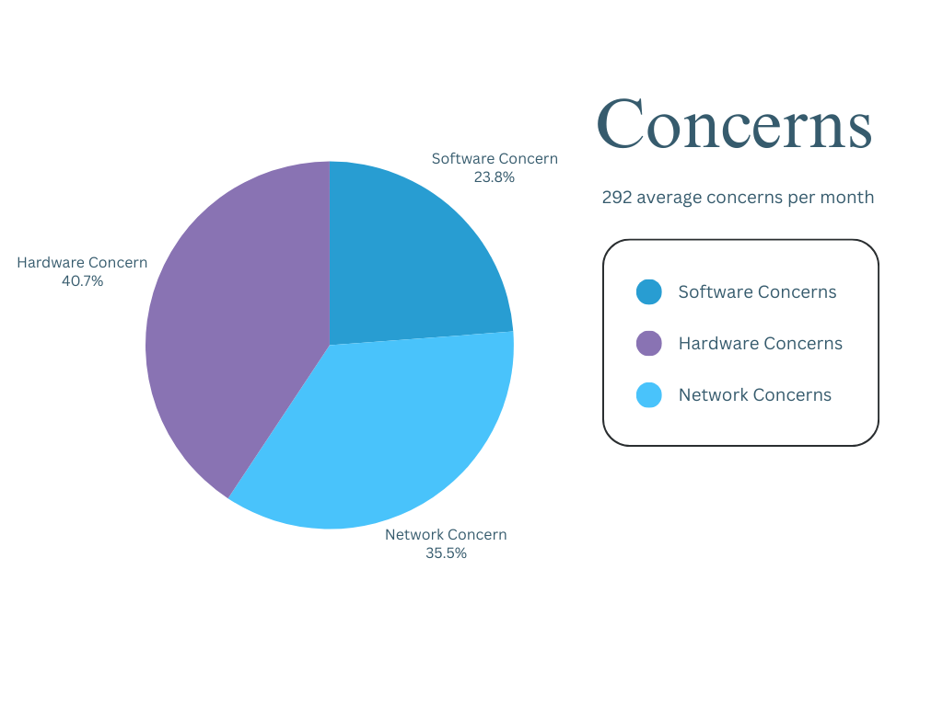

*Figure 1: Breakdown of the concerns dealt by ITS department monthly*

The closed-ended questions aimed to gauge participants' opinions on various aspects of the proposed IT Support Ticketing System. Responses were recorded on a scale from "Strongly Agree" to "Strongly Disagree."

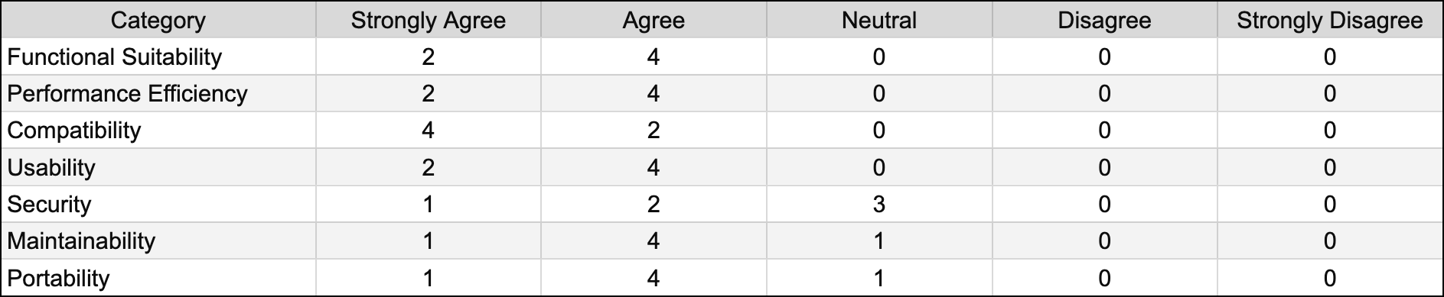

*Table 1: Summary of the responses on the closed-ended questions for the system evaluation*

Below are participant responses to open-ended questions, providing detailed feedback on their experiences with the IT Support Ticketing System.

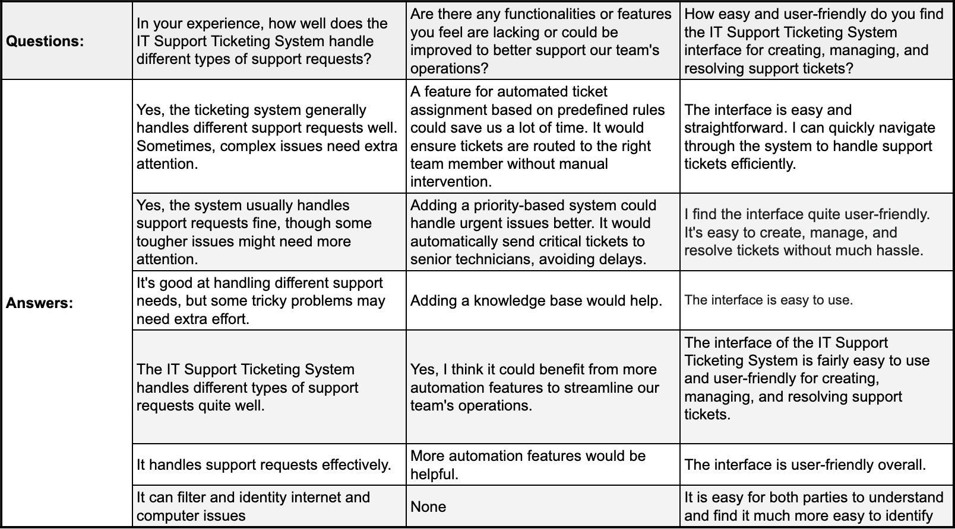

*Table 2: Responses on the open-ended questions for the system evaluation*

The following summarizes qualitative insights obtained from interviews, providing additional context to participants' perceptions and experiences with the IT Support Ticketing System.

* **Participant 1**: Expressed satisfaction with the system's ability to handle various support requests, suggesting occasional need for additional attention to complex issues.
* **Participant 2**: Appreciated the system's functionality but suggested adding priority-based features for urgent issues.
* **Participant 3**: Acknowledged the system's effectiveness but proposed the integration of a knowledge base.
* **Participant 4**: Highlighted the need for more automation features to streamline team operations.
* **Participant 5**: Reported overall satisfaction with the system's user-friendly interface.
* **Participant 6**: Found the interface easy to navigate, facilitating efficient support ticket management.

## Data Description

The study gathered data from distinct sources to comprehensively examine the IT support landscape at Systems Plus College Foundation. Firstly, monthly concerns breakdown unveiled an average of 292 IT concerns per month, with software concerns and others accounting for 19.2%, while network and hardware issues constituted 28.7% and 32.9%, respectively. Secondly, closed-ended questions, distributed through surveys, probed participants' perceptions across various dimensions of the IT Support Ticketing System, offering insights into its functionality, performance, compatibility, usability, security, maintainability, and portability. Thirdly, open-ended questions delved into qualitative aspects, prompting participants to share detailed experiences regarding support request handling, system functionalities, and user-friendliness. Lastly, interview findings, obtained through semi-structured interviews, provided deeper insights into participants' perspectives and experiences, enriching the understanding of the system's efficacy and usability. Together, these data sources facilitated a comprehensive exploration of the IT support ecosystem, blending different narratives to offer a holistic understanding of the system's performance and user satisfaction levels.

## Qualitative Findings

For the qualitative aspect, thematic analysis was employed to extract and categorize recurring themes from the open-ended survey responses and interviews, providing a deeper understanding of the challenges faced by end-users and the ITS team.

The analysis of the data revealed several key themes and patterns that shed light on the effectiveness and usability of the IT Support Ticketing System at Systems Plus College Foundation. Firstly, in terms of functional suitability, participants generally agreed that the system provided necessary features for managing support tickets efficiently. One participant remarked, "Yes, the ticketing system generally handles different support requests well. Sometimes, complex issues need extra attention." However, there were suggestions for improvement, such as the implementation of automated ticket assignment rules to streamline processes further.

Secondly, regarding performance efficiency, participants indicated satisfaction with the system's responsiveness to new support tickets. A participant commented, "The system responds quickly when a new support ticket is created."

Thirdly, in terms of usability, participants generally found the system's interface to be user-friendly for creating, managing, and resolving support tickets. One participant mentioned, "The interface is easy and straightforward. I can quickly navigate through the system to handle support tickets efficiently." However, suggestions for improvements in terms of adding a knowledge base to assist users were also highlighted.

Lastly, regarding security and maintainability, participants expressed confidence in the system's encryption measures to protect sensitive data. However, there were mixed responses regarding the ease of system updates and maintenance, with some participants suggesting room for improvement in documentation and frequency of updates.

The analysis revealed a generally positive perception of the IT Support Ticketing System's functionality and usability, with room for enhancements in areas such as automation, ticket assignment speed, and documentation.

## Discussions

## Interpretation

The interpretation of the research findings underscores several crucial insights into the efficacy and usability of the IT Support Ticketing System at Systems Plus College Foundation. Firstly, the data analysis indicates that the system generally meets the functional requirements expected of a support ticketing system. Users expressed satisfaction with its ability to handle different types of support requests efficiently, although there were occasional suggestions for enhancements, particularly in automating ticket assignment processes to streamline operations further. This finding suggests that while the system is generally effective, there is room for refinement to better align with user needs and optimize workflow efficiency.

Secondly, the research findings highlight the system's performance efficiency, with participants generally reporting prompt responses to new support tickets. However, concerns were raised regarding the speed of ticket assignment, indicating potential bottlenecks in the system's workflow. This underscores the importance of optimizing ticket routing mechanisms to ensure timely resolution of support issues and prevent delays that may impact user satisfaction and operational efficiency.

Thirdly, the data analysis reveals positive perceptions of the system's usability, with users finding the interface intuitive and user-friendly for managing support tickets. This suggests that the system design effectively facilitates the creation, management, and resolution of support tickets, contributing to a seamless user experience.

The research findings provide valuable insights into the strengths and areas for improvement of the IT Support Ticketing System. By understanding user perceptions and experiences, organizations can make informed decisions to optimize system functionality, improve performance efficiency, and enhance usability, ultimately fostering a more effective and user-centric support environment.

## Comparison with Previous Research / System

Comparing our study's findings with previous research or systems offers insights into the IT Support Ticketing System's performance. The system showcased strengths in functionality, performance, usability, and compatibility, aligning with industry standards. However, areas for improvement, like automated ticket assignment and knowledge base integration, were identified, consistent with existing literature. The interview findings provided qualitative depth, enhancing our understanding. This comparison enabled organizations to benchmark against industry standards, identify improvement areas, and enhance IT support operations.

## Limitations

The study's limitations primarily stem from its focus on Systems Plus College Foundation, which could restrict the generalizability of findings to other educational institutions. While the research provides valuable insights into the efficacy of the IT Support Ticketing System within this context, extrapolating these findings to broader settings may require caution. Since individuals may have varying perceptions and experiences with the ticketing system, their feedback could be influenced by personal biases or subjective interpretations. Therefore, while the study offers valuable insights into the system's performance, these limitations underscore the importance of considering contextual factors and potential biases when interpreting the results.

## Potential Implications

The practical implications of this research are significant, offering valuable insights that can inform real-world practices and decision-making processes. Firstly, the findings shed light on the effectiveness of the IT Support Ticketing System, providing actionable information for Systems Plus College Foundation and similar institutions to enhance their IT support processes. By understanding the system's strengths and areas for improvement, decision-makers can implement targeted strategies to optimize its functionality and usability.

Moreover, the study's identification of common concerns, such as software, network, and hardware issues, offers practical guidance for resource allocation and prioritization within the IT support department. Institutions can use this information to allocate resources more efficiently, ensuring that critical issues receive prompt attention and resolution. Additionally, the breakdown of concerns by category can inform proactive measures to address recurring issues, such as investing in software updates or hardware maintenance to mitigate future disruptions.

From a policy perspective, the research underscores the importance of investing in robust IT support infrastructure and tools. Institutions may consider allocating resources towards the development and maintenance of advanced ticketing systems that align with the specific needs of their users.

Furthermore, the study highlights the value of ongoing feedback and evaluation in improving IT support services. By soliciting input from end-users and IT staff through open-ended questions and interviews, institutions can gain valuable insights into user

experiences and preferences. This feedback can then be used to drive continuous improvement initiatives, guiding the evolution of IT support practices and systems over time.

The research offers practical implications for policy, practice, and decision-making in the realm of IT support services. By leveraging the insights gleaned from this study, institutions can enhance their IT support processes, allocate resources more effectively, and ultimately improve the overall user experience and satisfaction with IT services.

## Future Research

Building on the findings of this research, several avenues for future exploration emerge that could enrich our understanding of IT support ticketing systems and their impact on organizational efficiency and user satisfaction. Firstly, future studies could delve deeper into the specific factors influencing user satisfaction with IT support services, beyond the functionality of the ticketing system itself. By examining variables such as response time, resolution rates, and the quality of interactions with support staff, researchers could uncover nuanced insights into the drivers of user satisfaction and dissatisfaction. Moreover, investigating the role of user training and education in improving IT support experiences could provide valuable guidance for institutions seeking to enhance user satisfaction and optimize support processes.

Additionally, future research could explore the long-term effects of implementing advanced ticketing systems on organizational performance and outcomes. By conducting longitudinal studies that track the evolution of IT support practices and user experiences over time, researchers could assess the sustainability and scalability of improvements made to ticketing systems. Furthermore, examining the relationship between IT support quality and broader organizational outcomes, such as employee productivity, customer satisfaction, and organizational resilience, could shed light on the strategic value of investing in robust IT support infrastructure. Overall, future research in this area has the potential to contribute valuable insights that inform organizational decision-making and shape the future of IT support services.

# CHAPTER 5 Conclusions and Recommendations

This chapter presents the conclusion and recommendations made by the researchers.

## Conclusion

The main research objectives of this study were to design, develop, and implement a Next-Gen IT LAN-Based Support Ticketing System that improves the efficiency, user experience, and collaborative capabilities of IT support processes. The study aimed to address the limitations of existing ticketing systems by incorporating advanced automation, user-focused design, and robust security measures.

The research findings indicate that the developed IT support ticketing system successfully addressed many of the shortcomings of existing systems. The system demonstrated improved efficiency in handling support requests, with a significant reduction in response time and ticket resolution. Users reported a more user-friendly interface, enhanced collaboration features, and better integration with other IT tools. Additionally, the system's automation capabilities streamlined workflows and increased overall productivity within IT support teams.

The data collected and analyzed during the study overwhelmingly supported the research questions. The findings closely aligned with the initial expectations, demonstrating that the IT support ticketing system effectively improved efficiency, user experience, and collaborative capabilities within IT support processes.

The research findings have significant practical implications for IT professionals, organizations, and policymakers. The developed Next-Gen ticketing system offers a viable solution for organizations seeking to enhance their IT support processes. Its advanced features and user-centric design can improve productivity, streamline workflows, and ultimately lead to better service delivery. Policymakers can leverage these findings to advocate for the adoption of modern IT support solutions that prioritize efficiency and user satisfaction.

This study contributes to the broader field of IT by providing a comprehensive understanding of the challenges faced in IT support ticketing systems and offering a practical solution to address these challenges. The developed Next-Gen system adds to the existing body of knowledge by showcasing innovative approaches to improving efficiency and user experience in IT support processes. Furthermore, the study identifies gaps in current ticketing systems and offers insights into how future research can further enhance IT support operations. Overall, this research offers a unique perspective on optimizing IT support processes through automation and user-focused design principles.

## Recommendations

1. Long-term Evaluation: Conduct longitudinal studies to assess the long-term effectiveness and sustainability of the Next-Gen IT support ticketing system in various organizational settings.
2. Integration of Emerging Technologies: Explore the integration of artificial intelligence and machine learning to enhance the capabilities of IT support ticketing systems, including predictive analytics for proactive support.
3. User Training and Support: Develop comprehensive training programs for IT support teams and end-users to maximize the benefits of the new system, ensuring they are well-versed in utilizing all its features effectively.
4. Continuous Improvement: Implement a feedback loop mechanism to continually gather user feedback and incorporate it into regular system updates, ensuring the system evolves to meet changing user needs and technological advancements.
5. Scalability Assessments: Regularly evaluate the system’s scalability to ensure it can handle increased loads as organizational needs grow, maintaining high performance and reliability

## Conclusion Statement

This study sought to address the limitations of existing IT support ticketing systems by designing, developing, and implementing a Next-Gen IT LAN-Based Support Ticketing System. The primary objectives were to enhance efficiency, user experience, and collaboration within IT support processes through advanced automation, user-focused design, and robust security measures.

The findings demonstrated that the developed system significantly improved support request handling, reduced response times, and enhanced overall productivity. Users reported a more intuitive interface and better integration with other IT tools, validating the system's effectiveness in addressing the identified limitations.

Unexpected insights gained during the research highlighted the complexity of IT support systems and the importance of continuous improvement based on user feedback. The interdisciplinary collaboration between researchers, IT professionals, and end-users proved invaluable in developing a solution tailored to practical needs.

In conclusion, this study underscores the critical role of efficient IT support ticketing systems in enhancing organizational productivity and user satisfaction. By leveraging advanced automation and user-centric design principles, the developed Next-Gen system offers a promising solution for optimizing IT support processes. As organizations increasingly rely on technology to drive innovation and growth, continued research in this area is essential for fostering digital transformation and achieving organizational success in the digital age.

# REFERENCES

Anees, M. (2021, July 9). How to Manage Team Collaboration with a Support Ticket System.

WorkHub | AI Powered Knowledge Management and Smart Work. https://workhub.ai/how-to-manage-team-collaboration-with-a-support-ticket-system/

Anthony, E. (2016, October 13). You’re in dangerous waters without a Helpdesk Ticketing System. N-Able.

https://[www.n-able.com/blog/youre-dangerous-waters-without-helpdesk-ticketing-syst](http://www.n-able.com/blog/youre-dangerous-waters-without-helpdesk-ticketing-syst) em

Ashby, E. (2023, November). What is a Ticketing System - Helpshift. Www.helpshift.com. https://[www.helpshift.com/glossary/ticketing-system/#:~:text=A%20ticketing%20syste](http://www.helpshift.com/glossary/ticketing-system/#%3A~%3Atext%3DA%20ticketing%20syste) m%20is%20a

Bennett, T. (2023, November 8). What is Self-Hosted Software | An Overview with Pros and Cons - DreamFactory Software- Blog. Blog.dreamfactory.com. https://blog.dreamfactory.com/the-pros-and-cons-of-self-hosted-software-solutions

Ferreira, J. C., Filipe, P. P., Gomes, C., Cunha2, G., & Silva, J. (2013). Taas – Ticketing as a Service. Proceedings of the 3rd International Conference on Cloud Computing and Services Science. https://doi.org/10.5220/0004356000770082

Gerstl, R. (2023, April 29). Better UX for support ticket systems. EverestEngineering. https://medium.com/everestengineering/better-ux-for-support-ticket-systems-875858a 50628

Giva. (2021, July). How IT Support Software Can Modernize Technology in Schools. Giva. https://[www.givainc.com/blog/index.cfm/2021/7/6/how-it-support-software-can-mode](http://www.givainc.com/blog/index.cfm/2021/7/6/how-it-support-software-can-mode) rnize-technology-in-schools

Gohil, F., & Kumar, V. (2019, July). Ticketing System. Ticketing System; Florika Gohil1, Mr.

Vikash Kumar2. https://[www.researchgate.net/publication/334123740_Ticketing_System](http://www.researchgate.net/publication/334123740_Ticketing_System)

Goswami, G. (2017, April 21). 7 Key Benefits of Using Ticketing Software. Techjockey.com Blog. https://[www.techjockey.com/blog/ticketing-software-benefits](http://www.techjockey.com/blog/ticketing-software-benefits)

Grace, T. (2022, August). What is a ticketing system and how does it improve your business?

Talkdesk. https://[www.talkdesk.com/blog/ticketing-system/](http://www.talkdesk.com/blog/ticketing-system/)

Kumar, M. V., & Gohil, F. (2019). Ticketing System. International Journal of Trend in Scientific Research and Development, Volume-3(Issue-4). https://[www.ijtsrd.com/engineering/information-technology/23603/ticketing-system/f](http://www.ijtsrd.com/engineering/information-technology/23603/ticketing-system/f) lorika-gohil

Manjaly, S. (2022, August). Help Desk Software for Schools: Features, Goals and Options.

Blog.invgate.com. https://blog.invgate.com/building-a-help-desk-for-a-school

Mendes Lübeck, R., Wittmann, M. L., & Flores Battistella, L. (2012). Electronic Ticketing System As a Process of Innovation. Journal of Technology Management & Innovation, 7(1), 17–30. https://doi.org/10.4067/S0718-27242012000100002

Neefs, J., Schrooyen, F., & Doggen, J. (2015). Sci-Hub | Paper Ticketing vs. Electronic Ticketing Based on Off-Line System “Tapango.” 2010 Second International Workshop on Near Field Communication | 10.1109/NFC.2010.24. Sci-Hub.se. https://sci-hub.se/https://ieeexplore.ieee.org/abstract/document/5476473

Ngarianto, H., Mulaputra, A. F., Septiany, F., & Delima, T. (2023). Analysis and Design of Ticketing Application System (Case Study: Bebek Kaleyo). Engineering, MAthematics and Computer Science Journal (EMACS), 5(3), 161–167. https://doi.org/10.21512/emacsjournal.v5i3.10699

Pandey, A., Chanda, S., Mondal, M., & Karn, A. (2022, June). Comparison between LAN based and Web based application software. Comparison between LAN Based and Web Based Application Software; Abhishek Pandey Sourav Chanda Sourav Chanda Mithu Mondal Mithu Mondal Anushka Karn Anushka Karn. https://doi.org/10.13140/RG.2.2.12096.20484

Radosavljevic, L. (2021, March 17). Pros and Cons of Self-Hosting Your Help Desk Platform.

Helpy.io. https://helpy.io/blog/pros-and-cons-of-self-hosting-your-helpdesk-platform/

Robinson, C. (2017, August 23). How Freshdesk Helps You Make Data-driven Decisions.

Financesonline.com. https://financesonline.com/freshdesk-helps-make-data-driven-decisions/

Sancho, C. A., & Melendres, U. (2021). Development of Dynamic Local Area Network (LAN) Based Mock Board Examination System. International Journal of Computing Sciences Research, 5(1), 502–518. https://doi.org/10.25147/ijcsr.2017.001.1.55

Systems Plus College Foundation. (n.d.). History | Systems Plus College Foundation.

Www.spcf.edu.ph. https://[www.spcf.edu.ph/history](http://www.spcf.edu.ph/history)

Vidjikant, S. (2022, June 20). Advantages of Data-Driven Decision Making. Softjourn Inc. https://softjourn.com/insights/data-driven-decision-making

## Appendix A Functional Decomposition of From Chaos to Order: Next-Gen IT Support Ticketing System

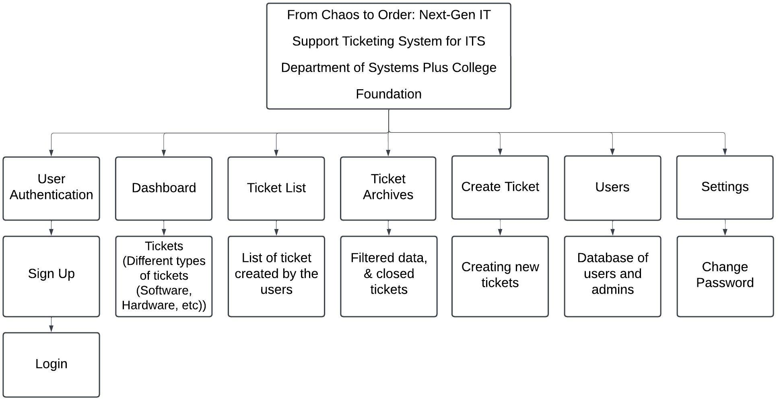

*Note*. The figure illustrates the process of creating, managing, and resolving support tickets, starting with user submission, sorting, assigning to the appropriate team, resolving the issue, documenting the solution, and closing the ticket.’

## Appendix B Functional Decomposition of From Chaos to Order: Next-Gen IT Support Ticketing System

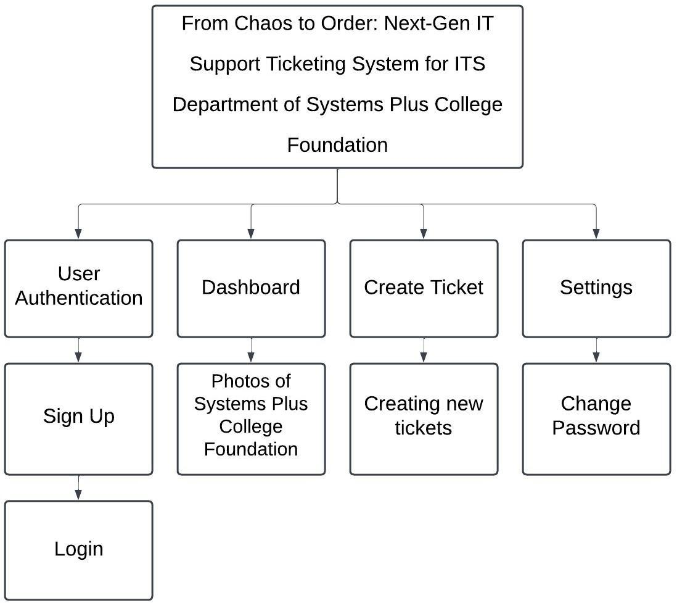

*Note*. The figure illustrates the workflow of an IT ticketing system, where a user opens a ticket via web portal, email, or phone, which is forwarded to the appropriate support team. After investigation, the team resolves the issue, escalating if necessary.

## Appendix C Design Criterion for From Chaos to Order: Next-Gen IT Support Ticketing System

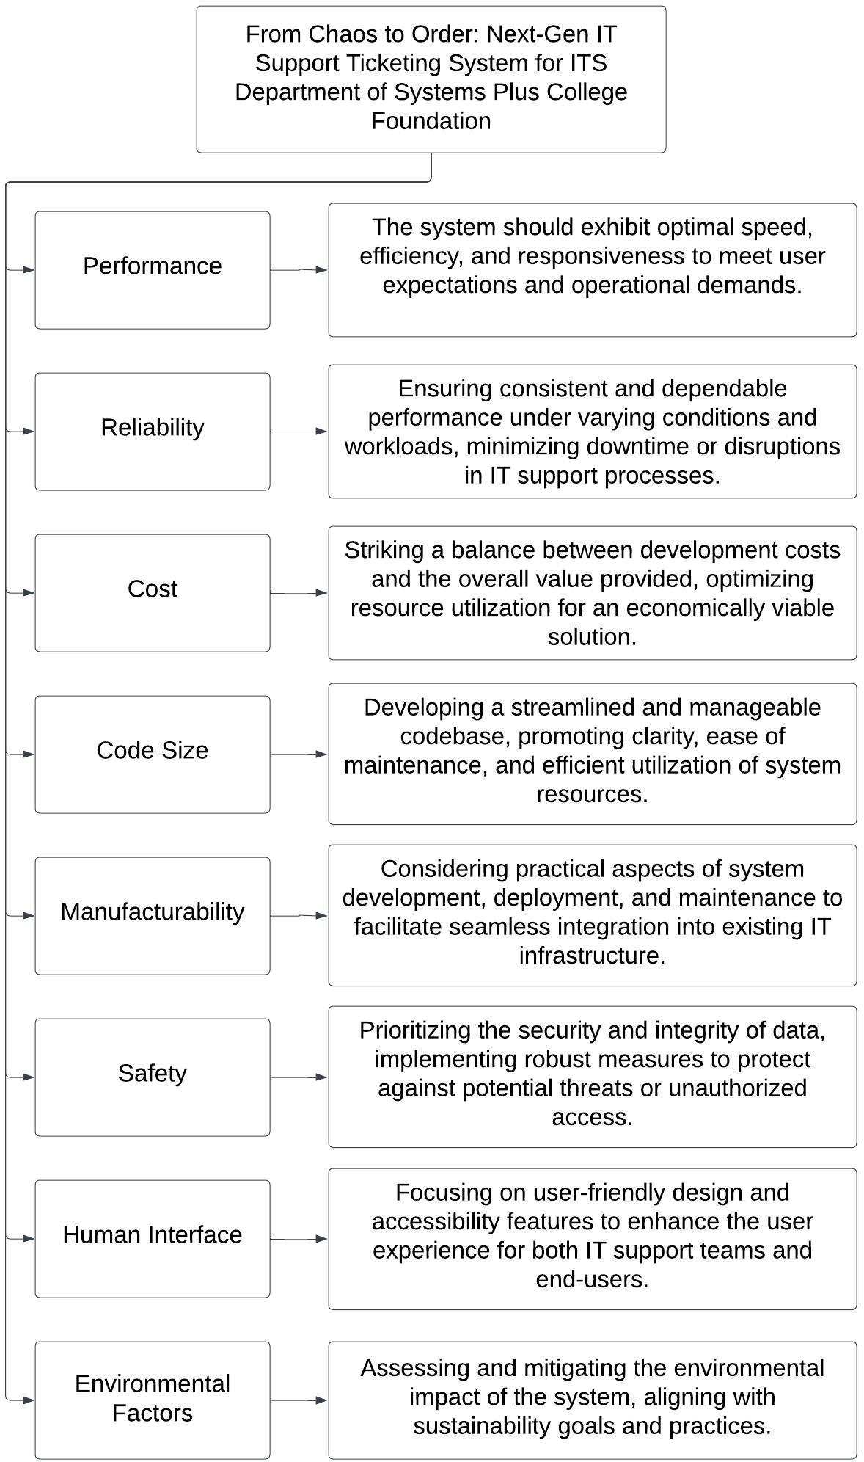

*Note*. The design criteria for the "From Chaos to Order: Next-Gen IT Support Ticketing System" emphasize optimal performance, reliability, cost-effectiveness, streamlined codebase, manufacturability, safety, user-friendly design, and environmental considerations. These criteria collectively aim to transform chaotic IT support processes into an organized and efficient system, ensuring a balance between functionality, usability, and sustainability.

## Appendix D System Interface User Account Page

1. **Login Page:** Users can securely access their accounts through a user-friendly login interface.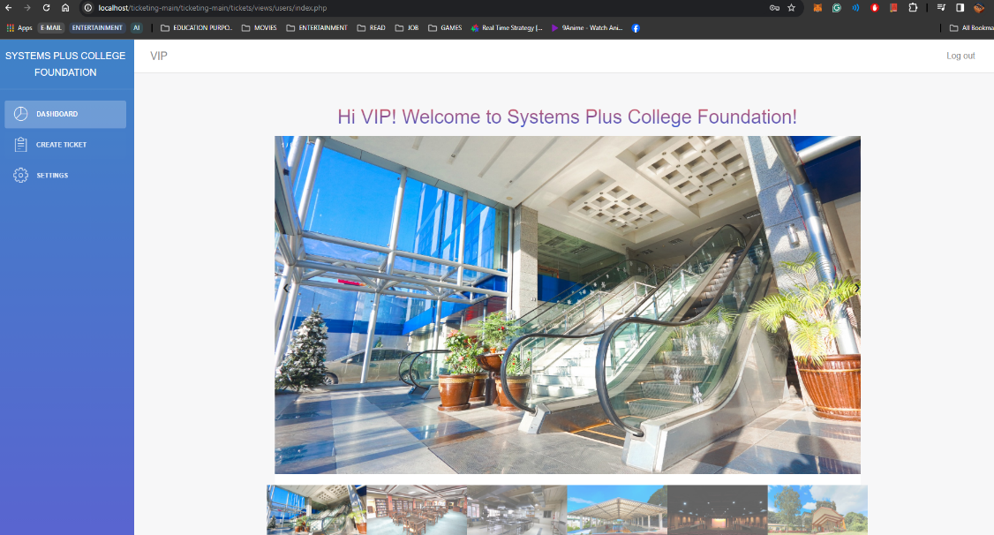
2. **Dashboard Tab**: Upon logging in, users are greeted with a welcoming dashboard. The background showcases the organization's unique visual identity.

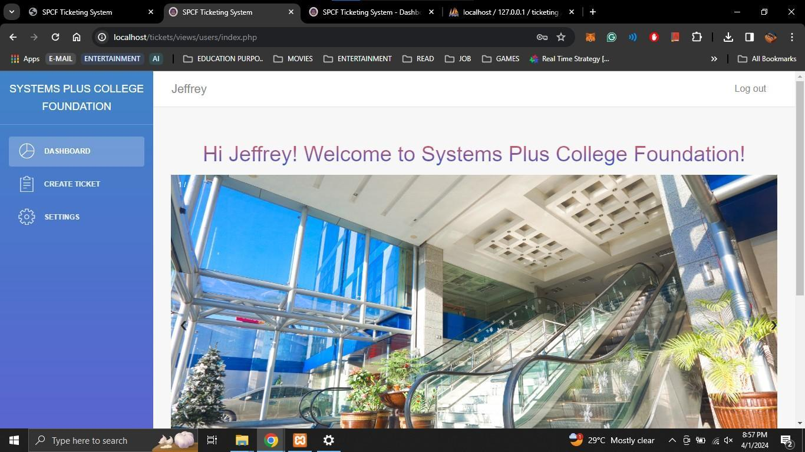

1. **Create Ticket Tab:** This section facilitates streamlined communication between users and support services. It features a Ticket Form section where users can submit their queries or requests efficiently. Moreover, the Ticket List section provides users with an overview of their submitted tickets, ensuring transparency and accountability in issue resolution.

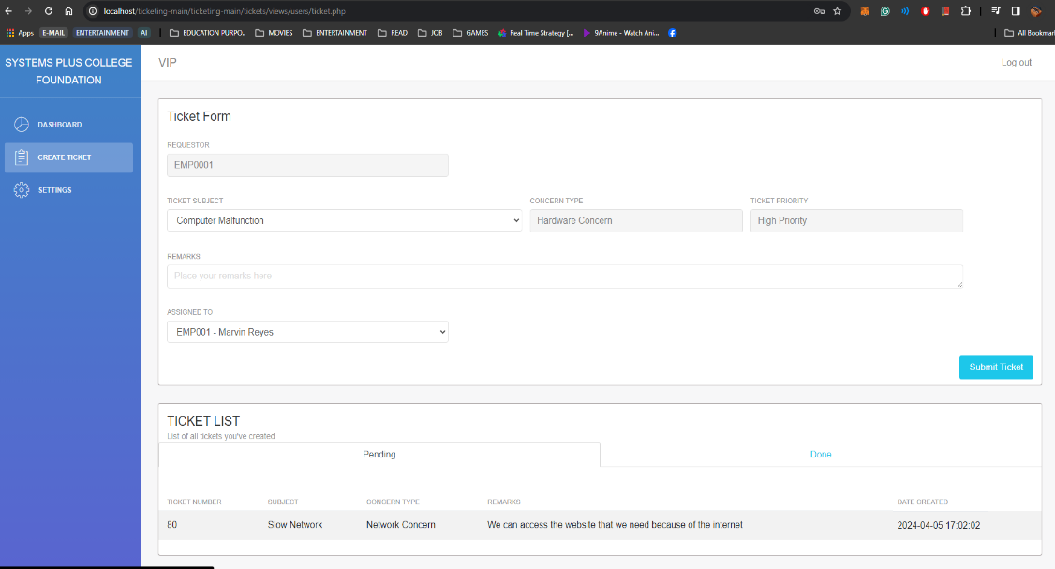

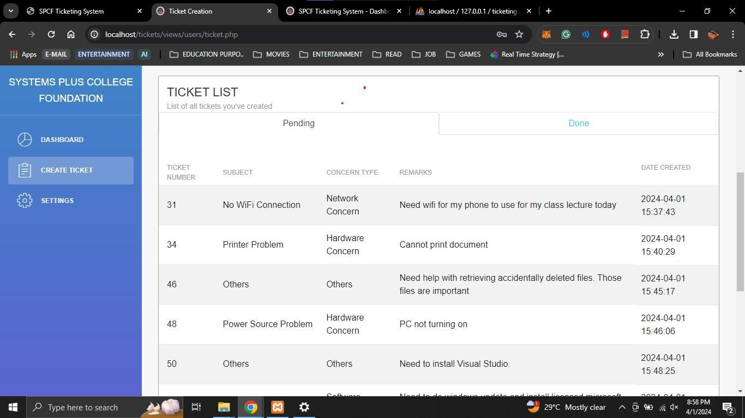

1. **Setting Tab:** Users can customize their account preferences effortlessly through the setting tab. A notable feature includes the ability to change passwords securely, empowering users to maintain account security proactively.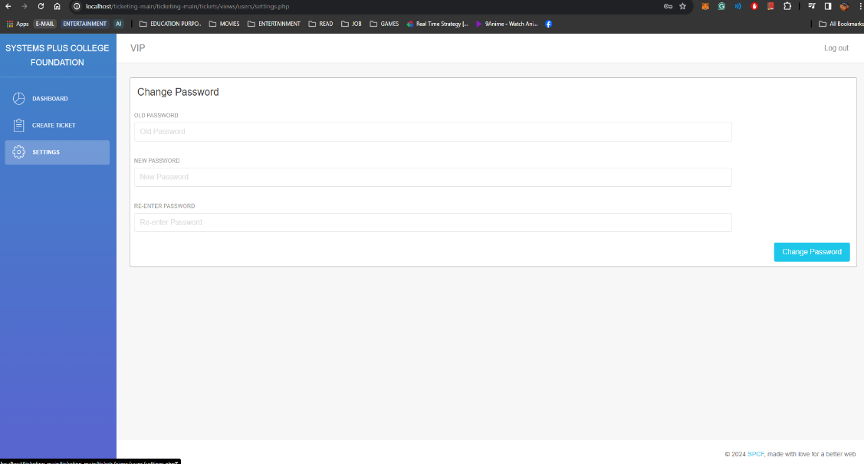

**Admin Account Page**

1. **Login Page:** Users can securely access their accounts through a user-friendly login interface.

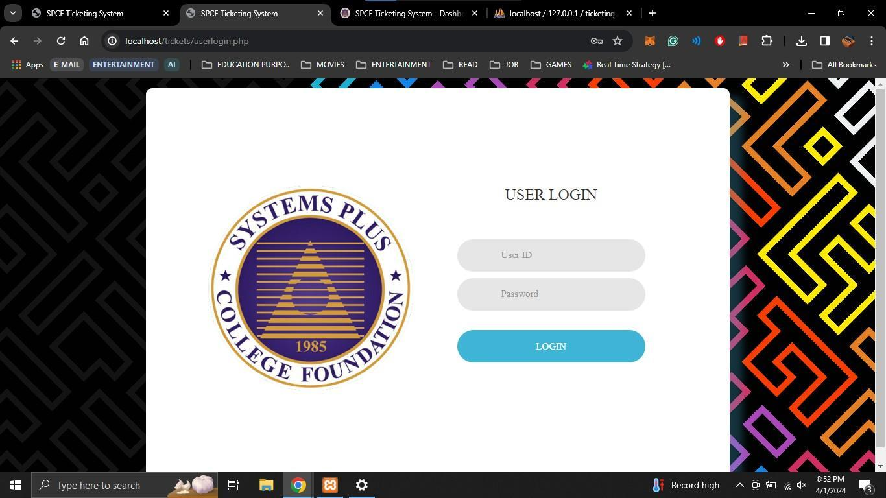

1. **Dashboard Tab**:

* **Software and Hardware Admin Dashboard:** This dashboard is tailored specifically for the Software and Hardware Administrators. It provides an intuitive interface that allows administrators to efficiently manage and monitor pending tickets related to software and hardware issues. 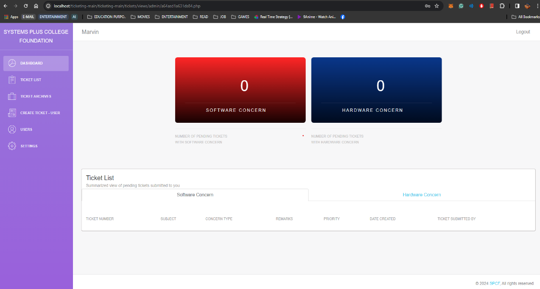
* **Network Admin Dashboard:** This dashboard is designed exclusively for Network Administrators. It focuses on providing a clear and concise view of pending tickets related to network concerns, facilitating effective issue resolution. 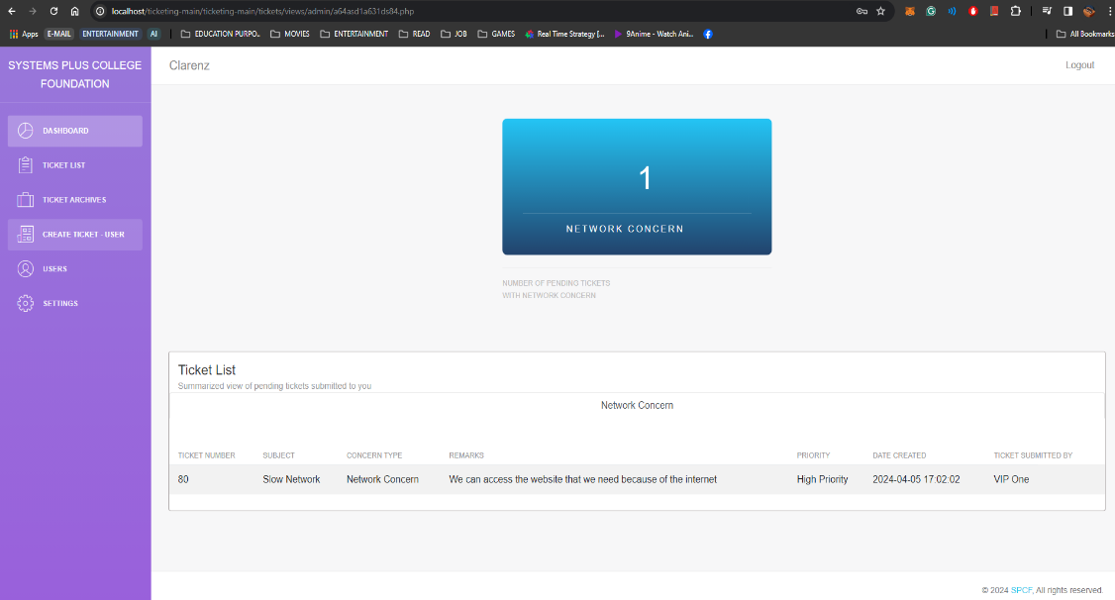

1. **Ticket List Tab:**

* **Ticket List Tab for Software and Hardware Admin:** provides a comprehensive list of all pending tickets related to software and hardware concerns. 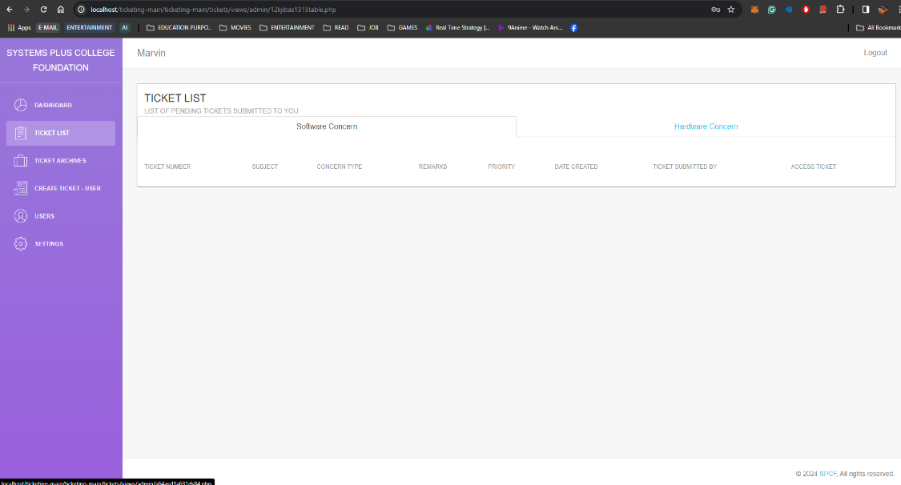
* **Ticket List Tab for Network Admin:** specifically tailored to display all pending tickets related to network concerns. 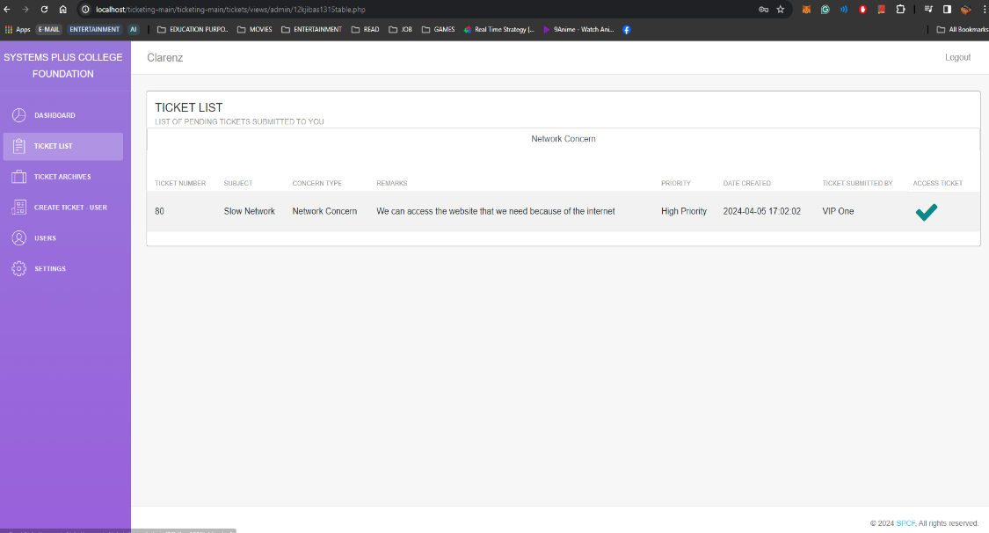

1. **Ticket Archives Tab:** Tallows administrators to access a historical record of all submitted tickets. This interface supports comprehensive filtering options, enabling administrators to retrieve specific tickets based on various criteria. The display of archived tickets is tailored according to the type of admin account: Software and Hardware Admin or Network Admin.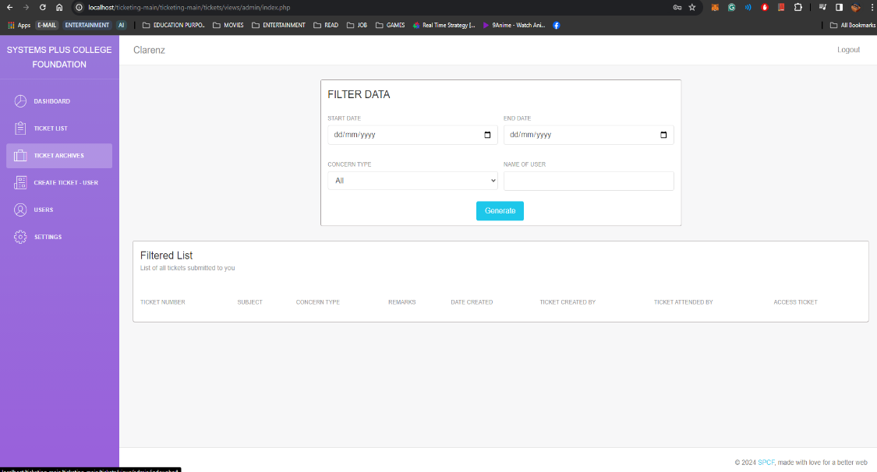
2. **Create Ticket for User Tab:** Allows administrators to create tickets on behalf of users who are unable to do so themselves. This functionality ensures that all issues are documented and addressed promptly, even if the user faces technical difficulties or other constraints that prevent them from submitting a ticket directly.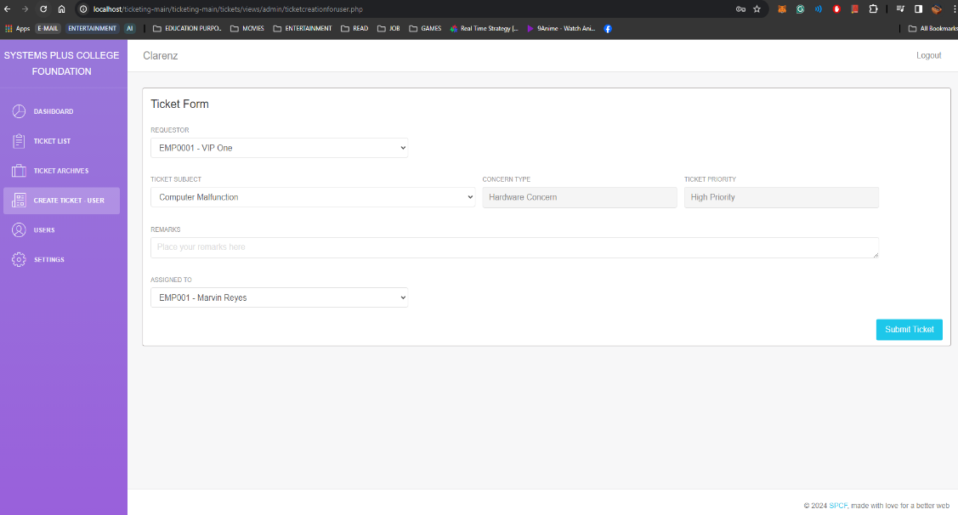**User Tab:** Allows administrators to manage user accounts efficiently. Administrators can create new user accounts, view a list of existing users, and perform various user management tasks.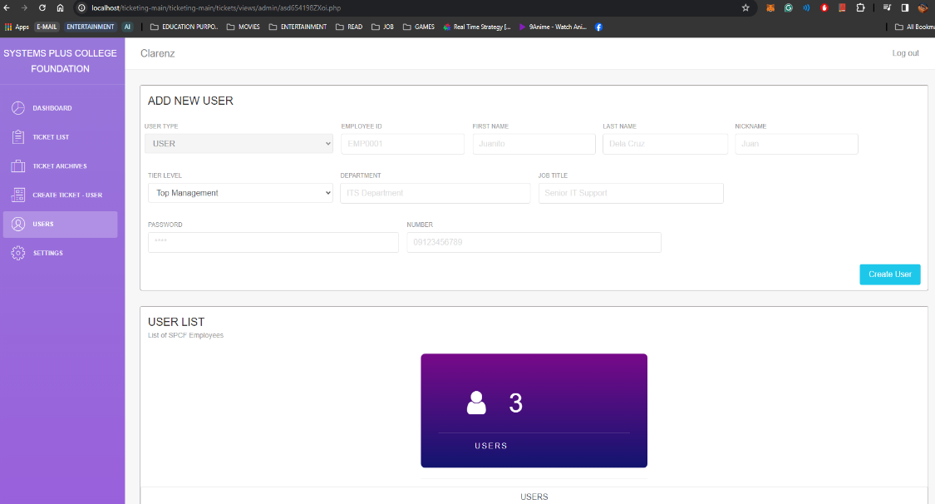
3. **Settings Tab:** Admins can customize their account preferences effortlessly through the setting tab. A notable feature includes the ability to change passwords securely, empowering admins to maintain account security proactively.

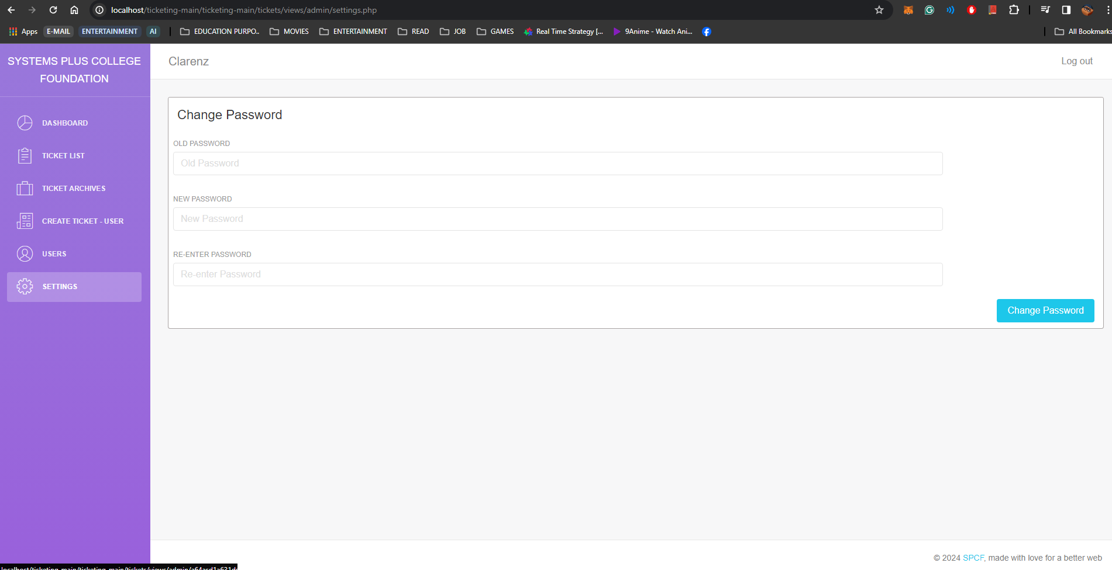

**Super Admin Page**

1. **Login Page:** Users can securely access their accounts through a user-friendly login interface.

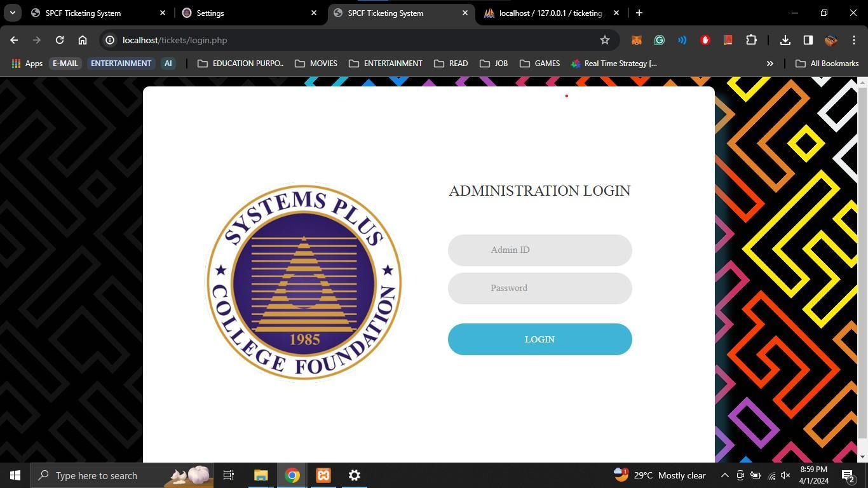

1. **Dashboard Tab:** Presents a summarized view of tickets created by users, providing quick insights into system activity and user engagement.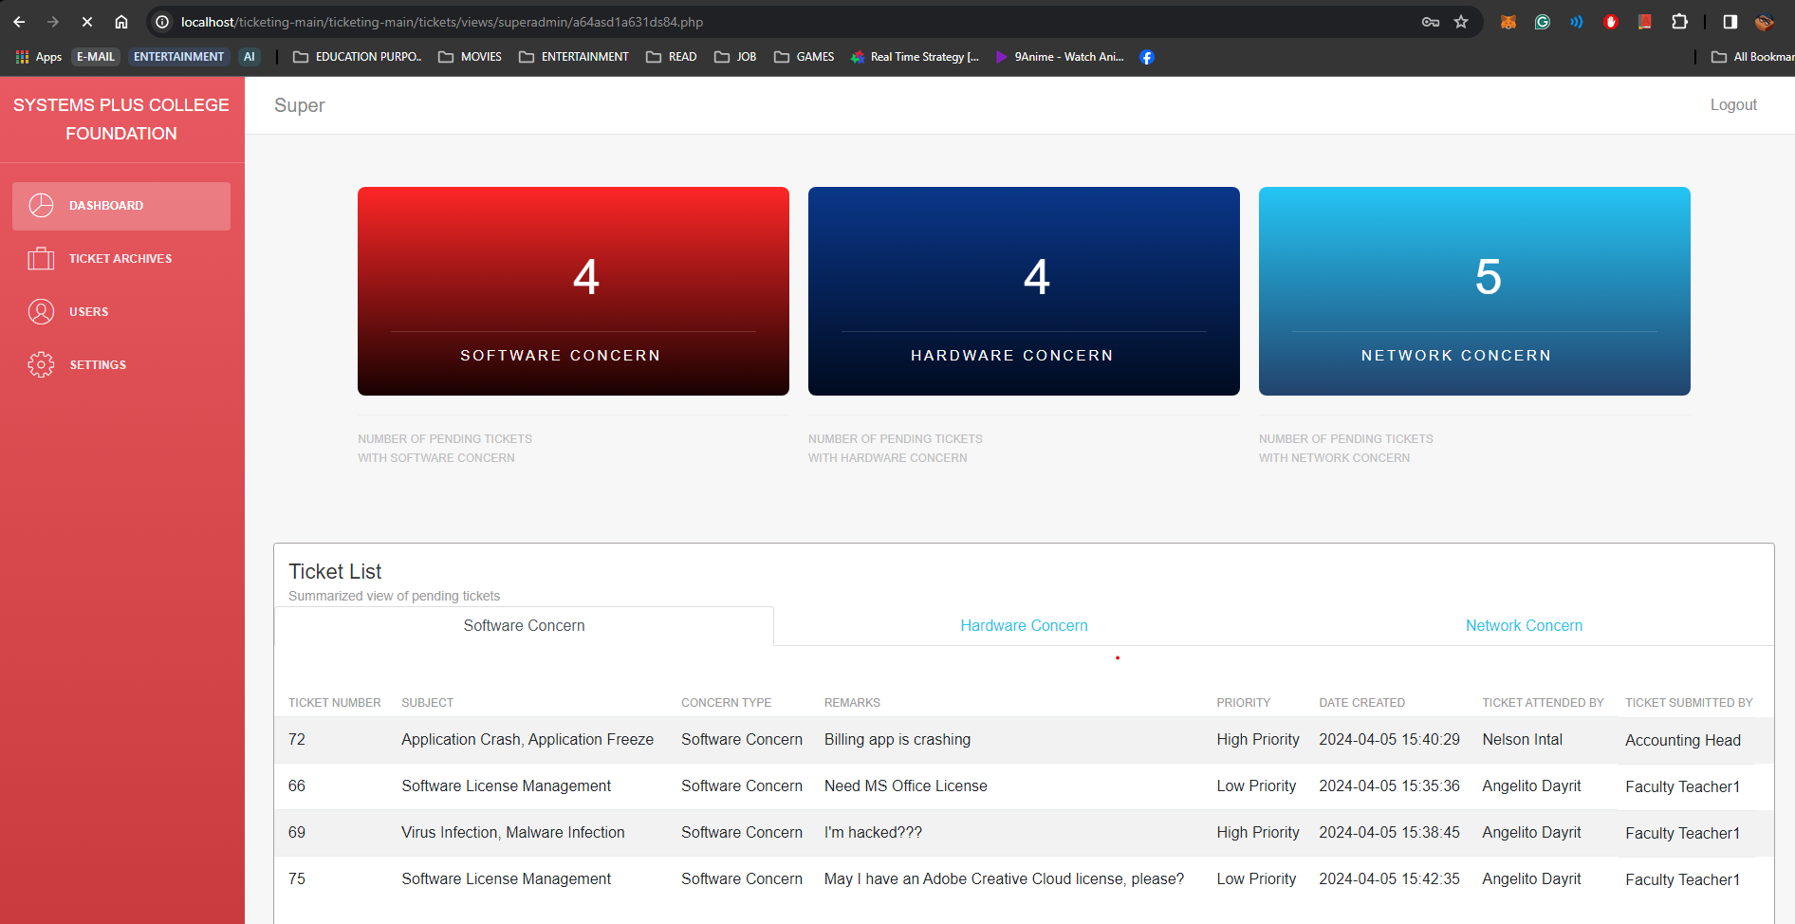
2. **Ticket Archives Tab:** Provides access to a comprehensive archive of all tickets created by users, along with advanced filtering options for enhanced data management.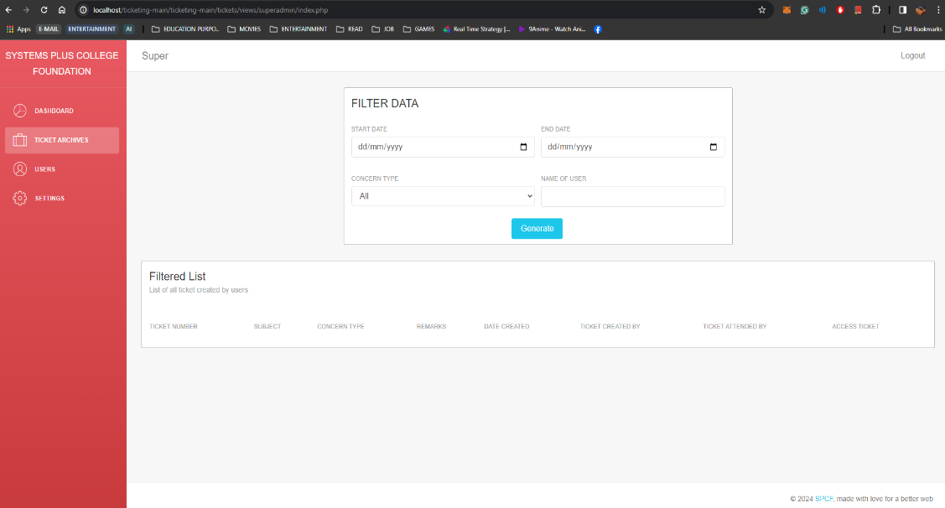
3. **User Tab:** Enables the Superadmin to manage user accounts, including the creation of new admin accounts. This tab provides functionalities to view, create, and manage all user accounts, ensuring effective user management and system administration.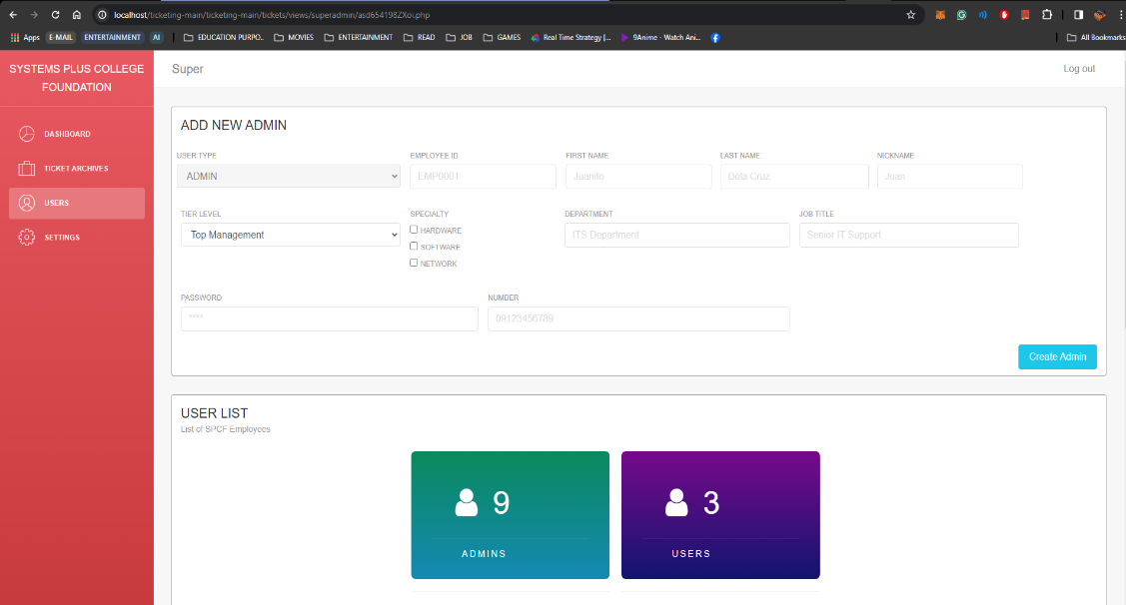
4. **Setting Tab:** Offers customizable settings, including password management, to ensure robust security and personalized user experiences.

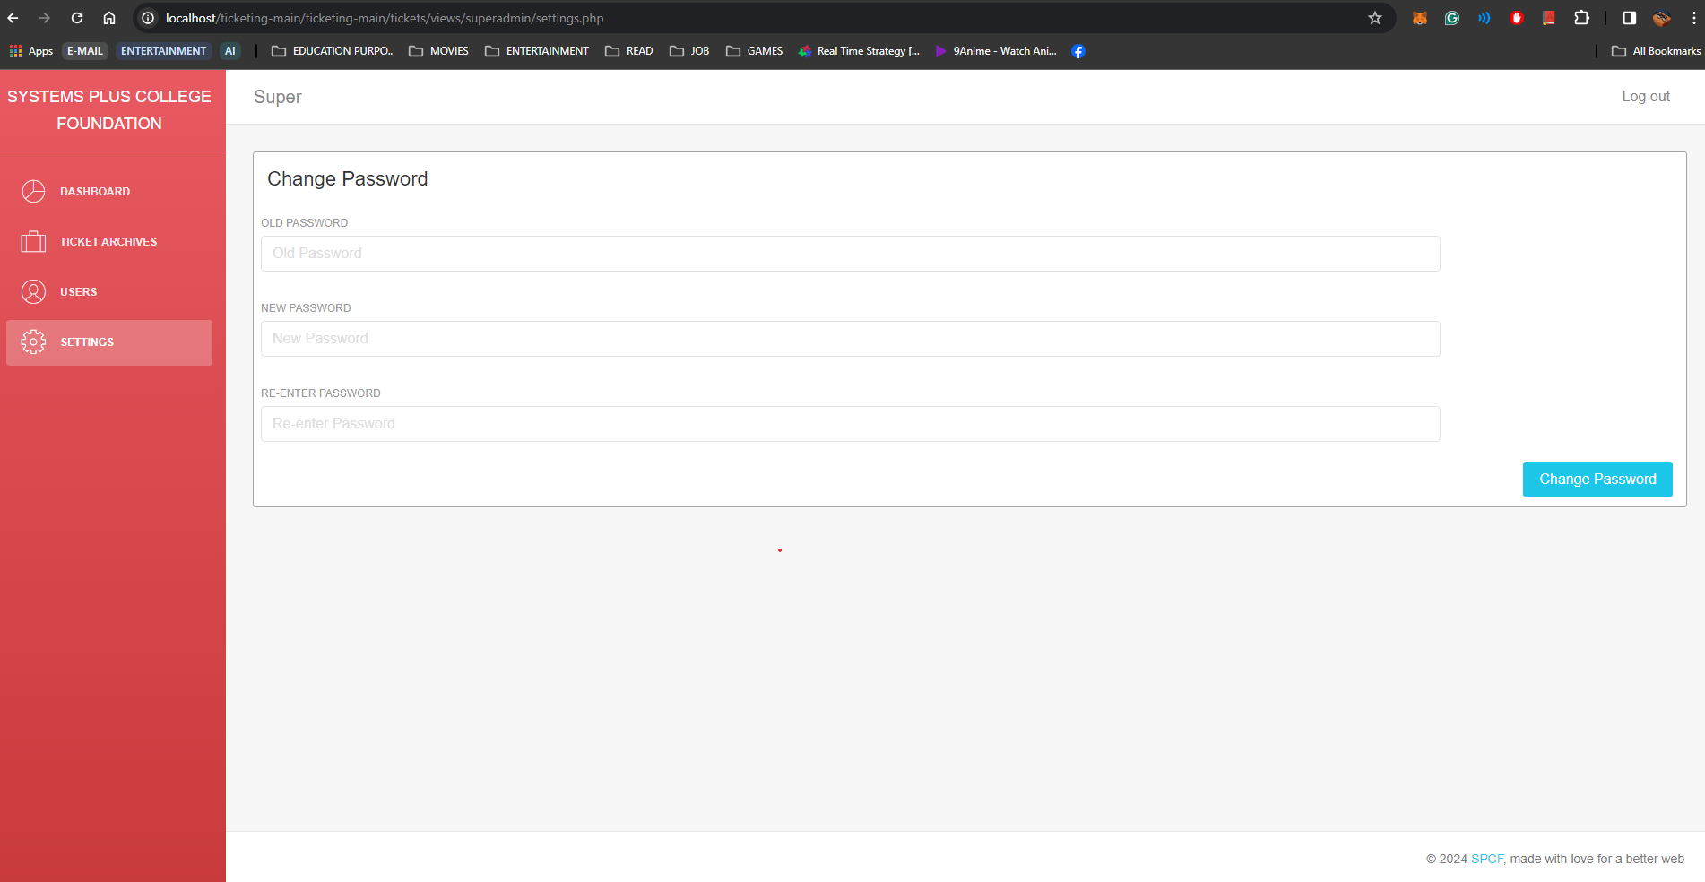

## Appendix E User’s Manual

**User's Manual for IT Support Ticketing System**

**Accessing the Ticketing System:**

* Open your web browser and navigate to the URL provided by your system administrator. You will be directed to the login page of the ticketing system.

**Login Page:**

* To access your account, visit the login page.
* Enter your username and password in the provided fields.
* Click the "Log In" button to proceed.



**Dashboard Tab:**

* Upon logging in, you'll be directed to the dashboard tab.
* Here, you'll be greeted with a warm welcome message.

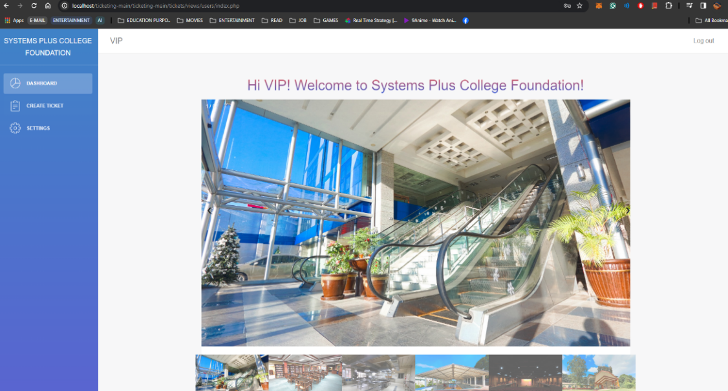

**Create Ticket Tab:**

* + To create a ticket, navigate to the "Create Ticket" tab.
  + In the Ticket Form section, fill out the required details.
  + Click the "Submit" button to create your ticket.
  + In the Ticket List section, you can view the status of your submitted tickets and

any updates from the support team.

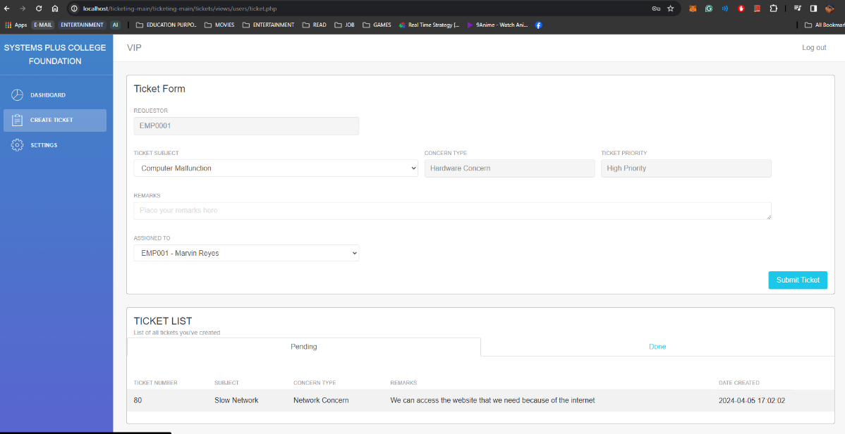

**Setting Tab:**

* To manage your account settings, go to the "Setting" tab.
* Here, you can change your password for added security.
* Simply enter your current password, followed by your new password and confirmation.
* Click the "Save Changes" button to update your password.

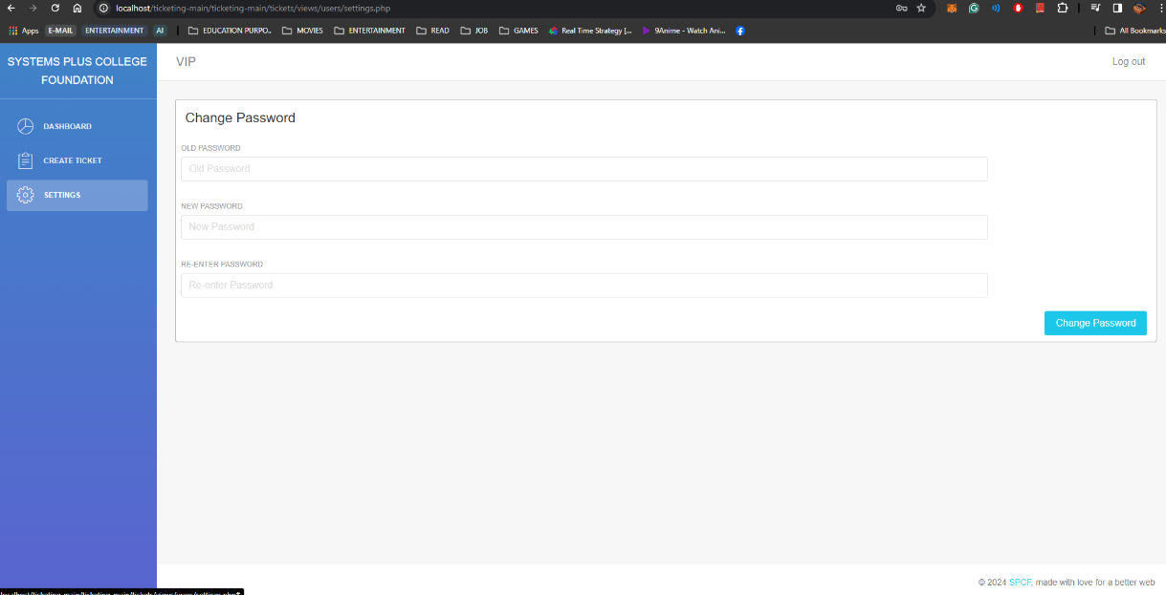

**Administrator Account**

**Admin User's Manual for IT Support Ticketing System**

**Accessing the Ticketing System:**

* Open your web browser and navigate to the URL provided by your system administrator.
* You will be directed to the login page of the ticketing system.User Authentication:
* **Sign Up:** Create a new user account if you haven’t already. This might be available to employees or students affiliated with the Systems Plus College Foundation.
* **Login:** Existing users can log in using their credentials.

**Logging In:**

* Enter your admin username and password in the respective fields.
* Click on the "Login" button to proceed.



**Dashboard**:

* After successful login, you will be directed to the dashboard.
* This section provides an overview of your recent activities and the overall ticketing system.
* Here, you will see pictures of systems and college foundation details.

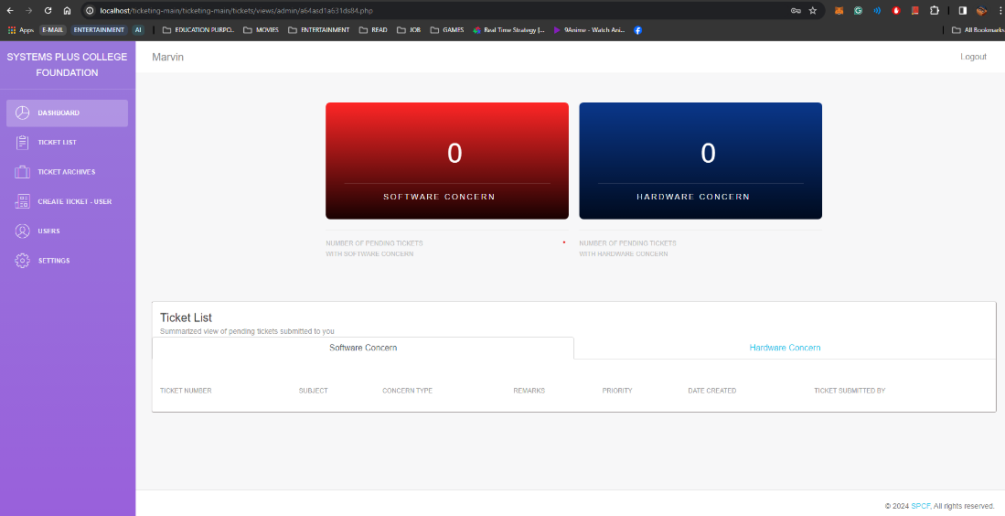

**Ticket List:**

* View a list of tickets you created or submitted. Use filters to narrow down the list according to various criteria.

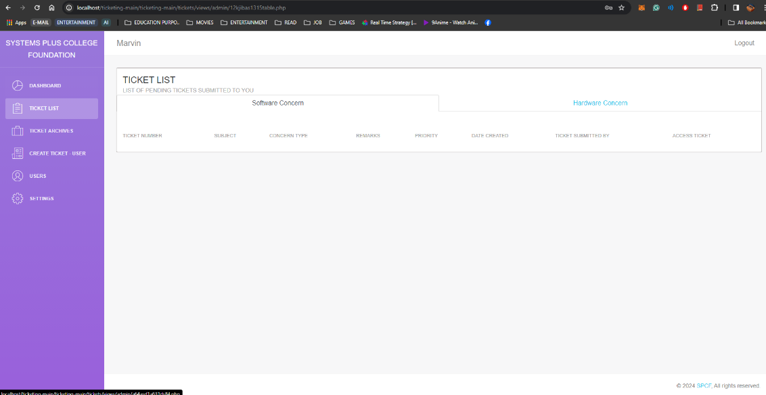

**Ticket Types:**

* Tickets are categorized based on the nature of the IT request (e.g., Software, Hardware, Network).

**Status**:

* Tickets are categorized based on their current status in the resolution process (e.g., Open, Pending, Resolved, Closed).Ticket Archives:
* Access resolved or closed tickets.

**Create Ticket:**

* To create a new ticket, go to the "Create Ticket" section.
* Fill out the ticket details including the issue or request description.
* Click on the "Submit" button to create the ticket.
* You can track the status of pending and completed tickets in this section.
  + Request Type: Specify the type of IT support needed (e.g., Software, Hardware, Network).
  + Description: Provide a clear and concise description of the IT issue. More details aid support staff in assisting you.
  + Attachments: Attach screenshots or relevant files to provide additional context to your IT request.

**Users**:

* Manage user accounts and permissions within the system if authorized.
* To create a new user profile, navigate to the "Create User Profile" page.
* Fill out the necessary information such as username, password, and user type.
* Click on the "Create User" button to add the new user to the system.
* You can also view the total number of users and administrators on this page.

**Settings**:

* To change your password, navigate to the "Settings" page.
* Enter your current password and then your new desired password.
* Click on the "Change Password" button to update your password.You can also logout by clicking on the logout button located at the top right corner of the interface.

**Logging Out:**

* Once you have completed your tasks, ensure to logout from the system.
* Click on the logout button located at the top right corner of the interface to securely log out of your account.

**Additional Notes:**

* Functionalities may vary depending on the ticketing system your organization uses.
* Consult with your IT department or system administrator for questions or difficulties.

## Appendix F Evaluation Tools

**Alpha Testing**

Alpha base testing, in which the researcher tests the entire system themselves, the researchers will put the system to the test.

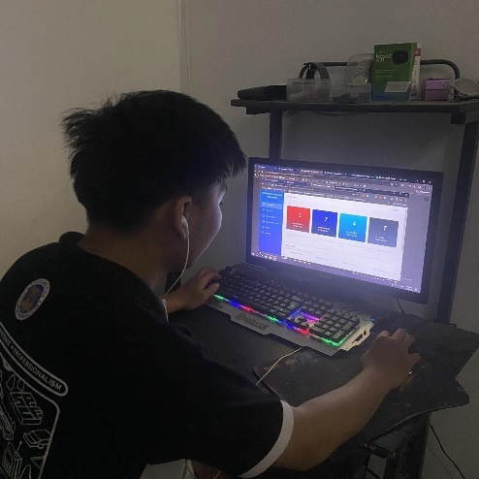 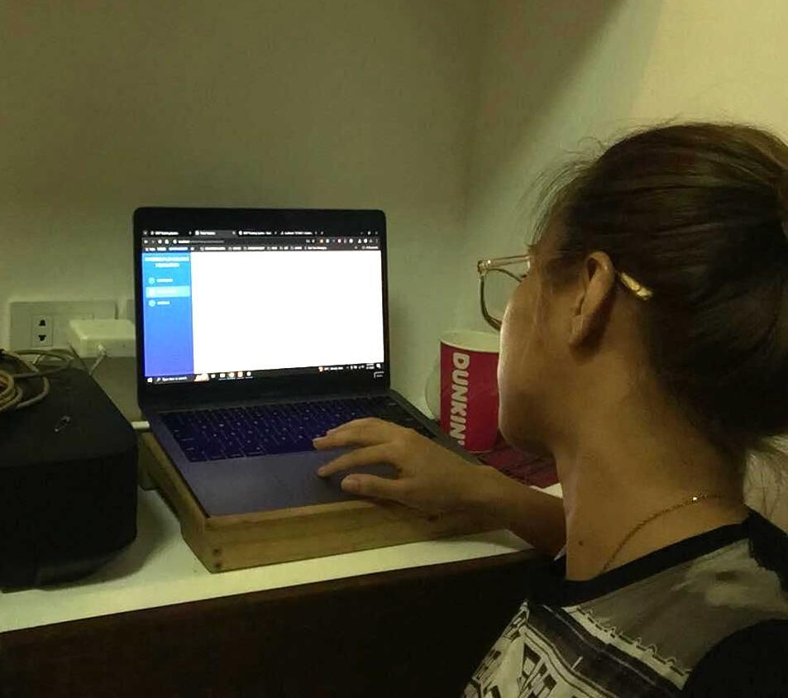

**Data Gathering**

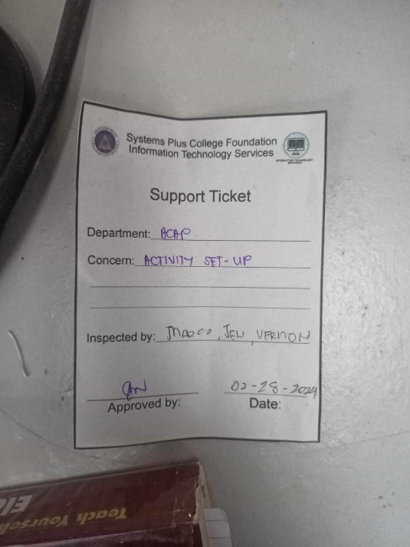 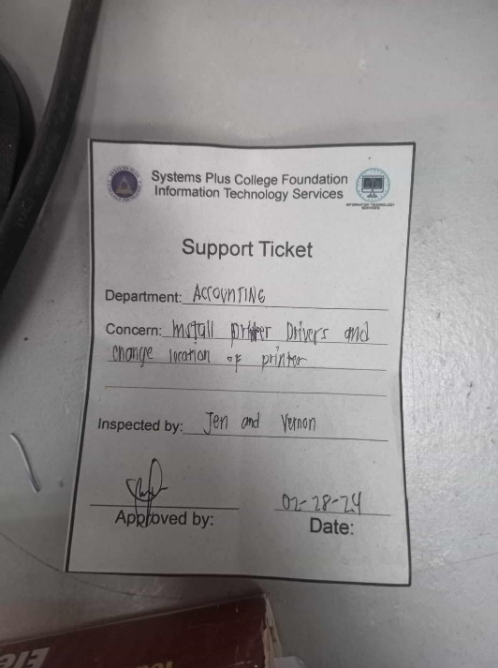

Current Support Ticket of the ITS Team

**Survey Questionnaire**

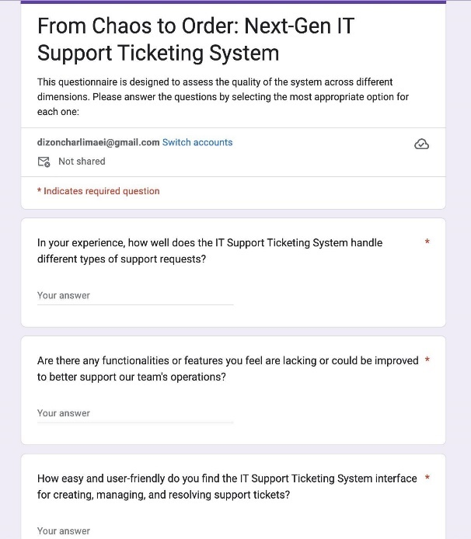 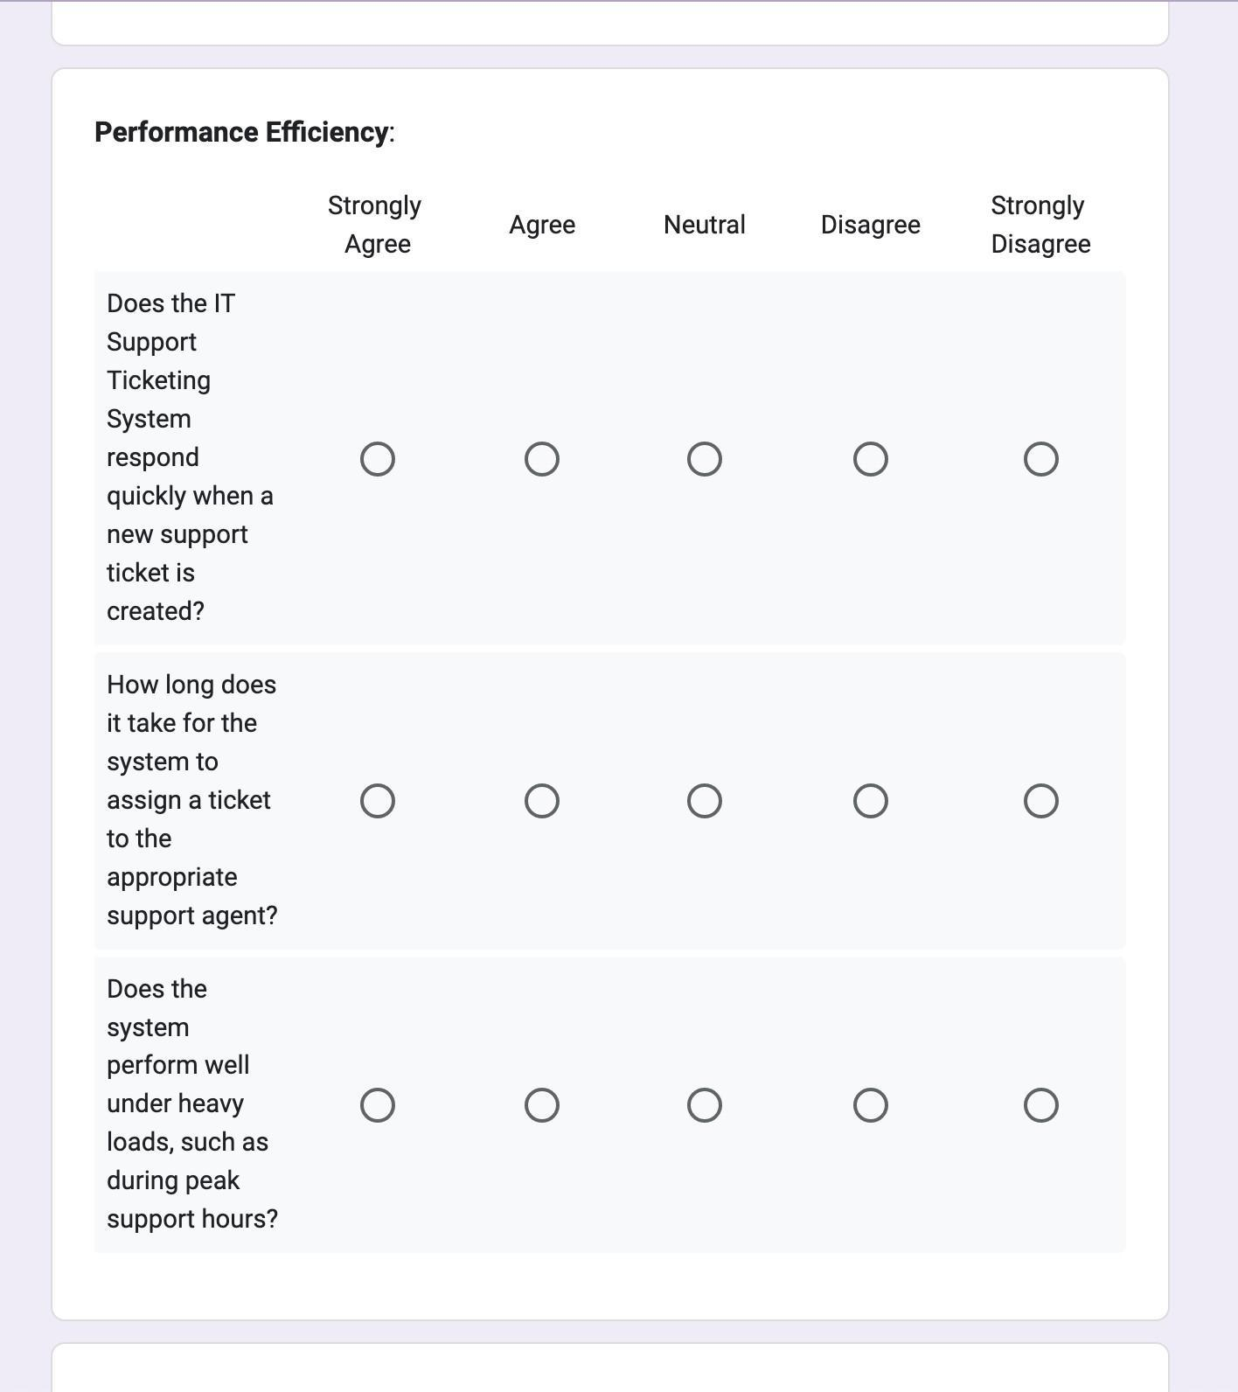

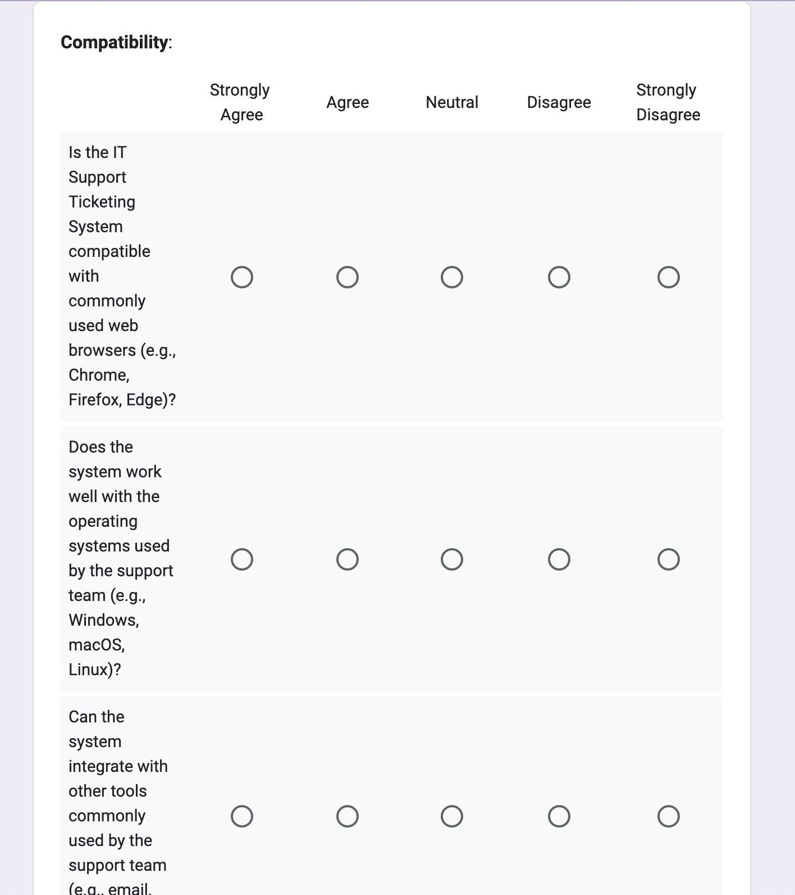 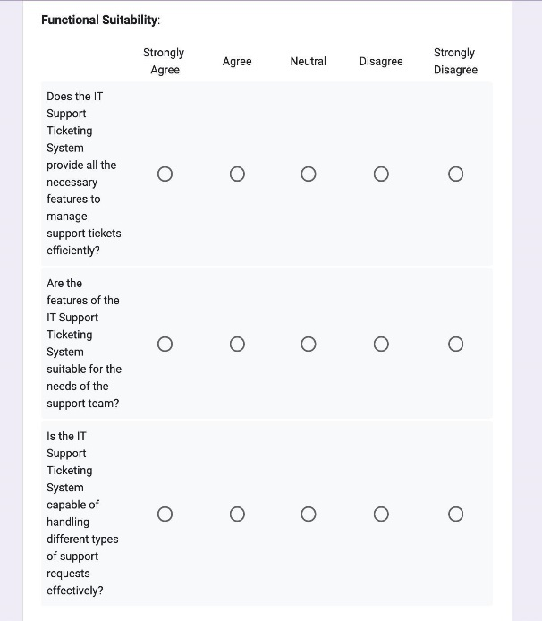

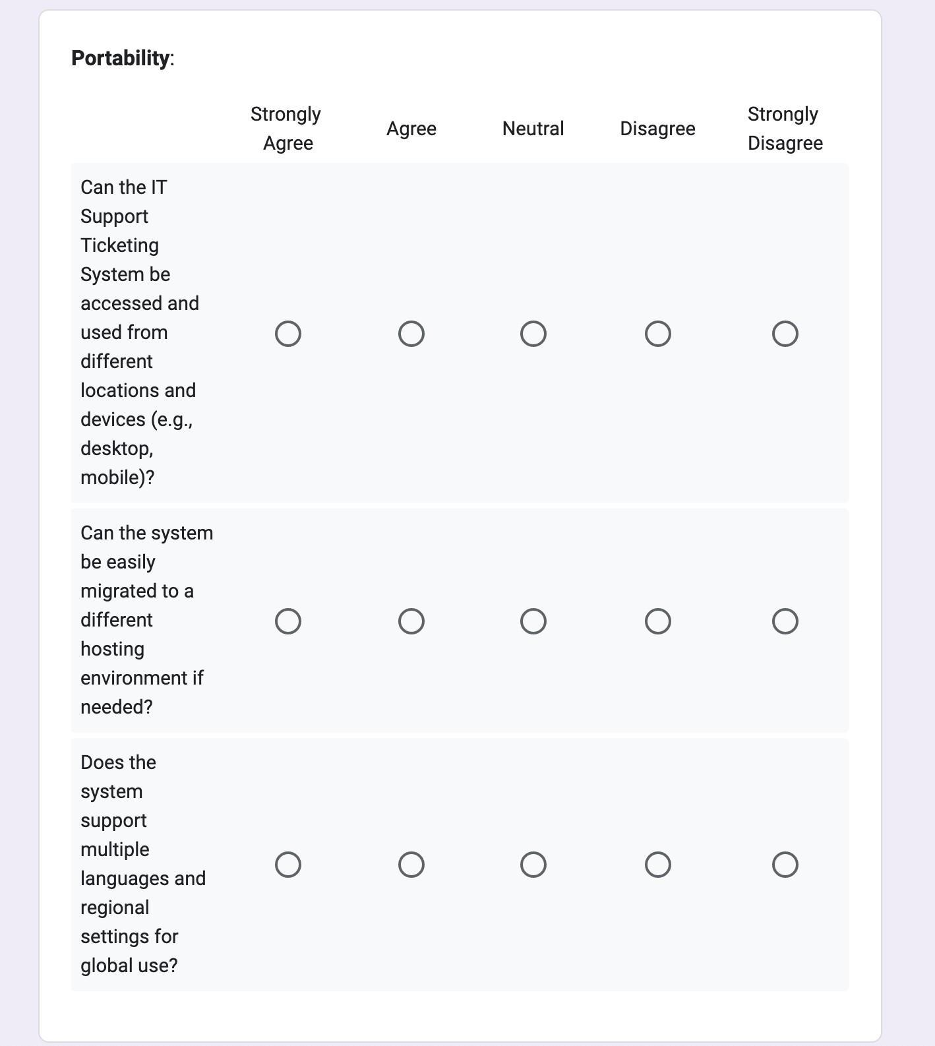 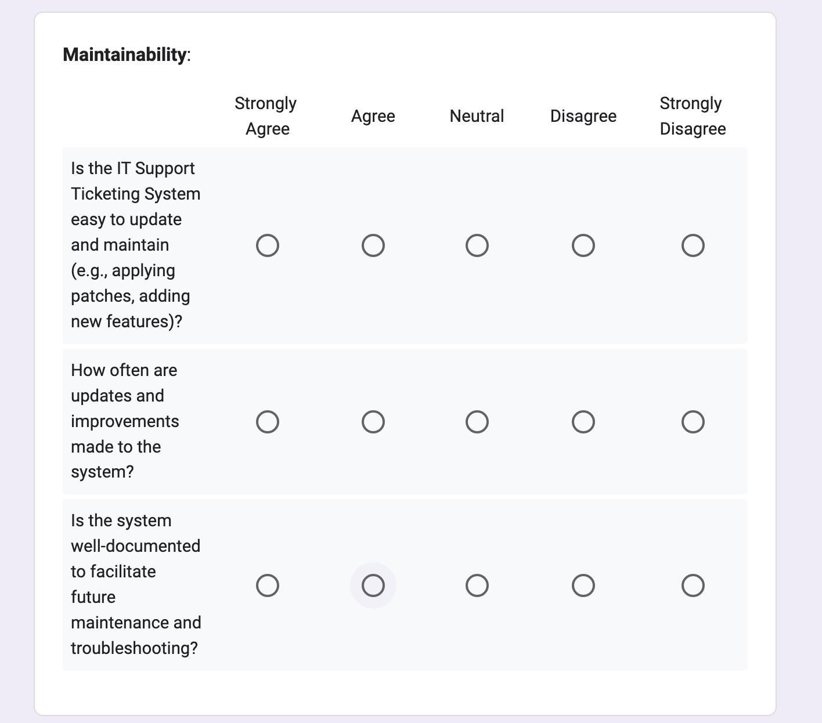

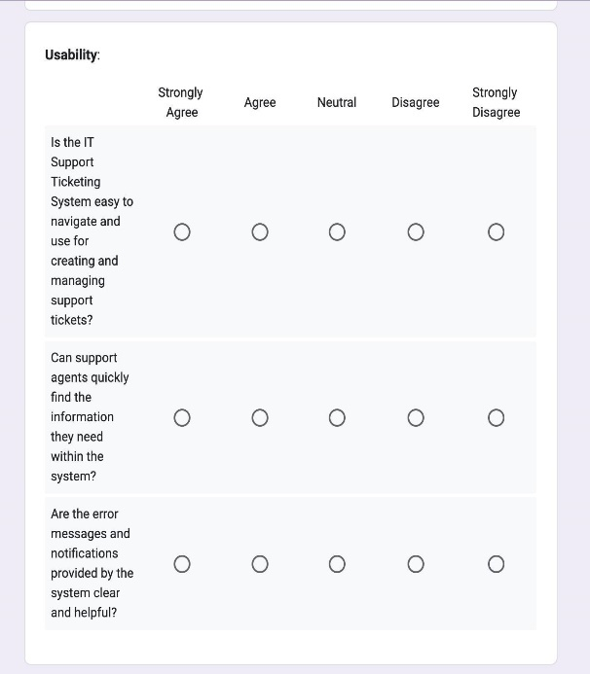 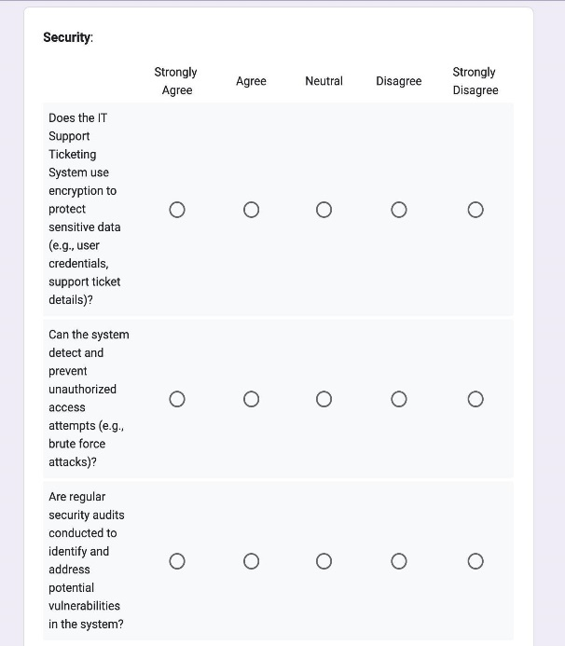

## Appendix G Curriculum Vitae

**Zyren C. Panao**72B Sitio Pader, Pulung Maragul, Angeles City, Pampanga  
[ccis.zyren.panao@gmail.com](mailto:ccis.zyren.panao@gmail.com)  
09621918753  
**Personal Information:**  
Date of Birth:August 12, 2001  
Place of Birth:Angeles City  
Citizenship:Filipino  
Sex:Male  
Age: 22  
Civil Status:Single  
Religion:Jehova’s Witness

**Educational Attainment:  
Bachelor’s/College Degree:** Systems Plus College Foundation (SPCF)BSIT - Network Administration  
 2024 **Senior High School:** Systems Plus College Foundation  
 TVL - ICT 2019-2020 **Junior High School:** Rafael L. Lazatin Memorial High School2017-2018

**Charli Maei S. Dizon**159 Ponciano Ave., Purok 5, Sta. Cruz, Porac, Pampanga dizoncharlimaei[@gmail.com](mailto:ccis.zyren.panao@gmail.com)09497998281 **Personal Information:**  
**Date of Birth:** January 6, 2002  
**Place of Birth:** Porac, Pampanga  
**Citizenship:** Filipino  
**Sex:** Female  
**Age:** 22  
**Civil Status:** Single  
**Religion:** Roman Catholic **Educational Attainment:  
Bachelor’s/College Degree:** Systems Plus College Foundation Balibago, Angeles City BSIT - Network Administration   
 2024  
**Senior High School:** Pulung Santol National High School TVL-ICT

2019-2020  
**Junior High School:** Pulung Santol National High School   
 2016-2017

**Liah May Q. De Luna**Colo, Dinalupihan, Bataan [liahmaydeluna@spcf.edu.](mailto:liahmaydeluna@spcf.edu.)ph 09279509214 **Personal Information:  
Date of Birth:** August 6, 2001 **Place of Birth:** Cabanatuan City, Nueva Ecija **Citizenship:** Filipino **Sex:** Female **Age:** 22 **Civil Status:** Single **Religion:** Roman Catholic  
  
**Educational Attainment:**  
**Bachelor’s/College Degree:** Systems Plus College Foundation   
 BSIT-Network Administration   
 2023-2024  
**Senior High School:** Jose C. Payumo Jr. Memorial High School  
 Academic -STEM  
 2019-2020  
**Junior High School:** Jose C. Payumo Jr. Memorial High School

2016-2017

**CHRISTIAN ERIC P. AQUINO**1061 Kalayaan St. Sta. Trinidad Angeles City, Pampanga [christianericaquino@gmail.com](mailto:christianericaquino@gmail.com)09364413370  
**Personal Information:  
Date of Birth:** March 26, 2000 **Place of Birth:** Angeles City **Citizenship:** Filipino **Sex:** Male **Age:** 24 **Civil Status:** Single **Religion:** Roman Catholic **Educational Attainment:  
Bachelor’s/College Degree:** Systems Plus College Foundation BSIT-Network Administration  2023-2024 **Secondary Education:** Sto.Rosario Elementary School  Alternative Learning System (ALS)  2016-201

**Rafael B. Umanos**Purok 6 Pulung Santol Porac Pampanga [rafaelbuan0889@gmail.com](mailto:rafaelbuan0889@gmail.com) 09196174090  
**Personal Information:  
Date of Birth:** July 15, 2002 **Place of Birth:** Porac, Pampanga **Citizenship:** Filipino **Sex:** Male **Age:** 21 **Civil Status:** Single **Religion:** Roman Catholic **Educational Attainment:  
Bachelor’s/College Degree:** Systems Plus College Foundation BSIT-Network Administration  2023-2024 **Senior High School:** Pulung Santol National High School Pulung  TVL-ICT 2019-2020 **Junior High School:** Pulung Santol National High School  2016-2017